

MANAV RACHNA UNIVERSITY

PYTHON COMPLETE LAB



HIMANSHU SINHA

B-TECH CSE 4A

2K18CSUN01064



**MANAV RACHNA UNIVERSITY, FARIDABAD**

**Department of Computer Science & Technology**

**Course: B.Tech(CSE/DTE) Semester:II/IV Subject: Programming for Problem Solving using Python(CSW208B) Session: 2019-20**

***Lab -3***

***Learning Outcome CO1*:** *Student will be able to implement Loops* ***Blooms Taxonomy Level****: BT2*, *BT3*

1. [**Check whether a number is even or odd**](https://www.programiz.com/python-programming/examples/prime-number)

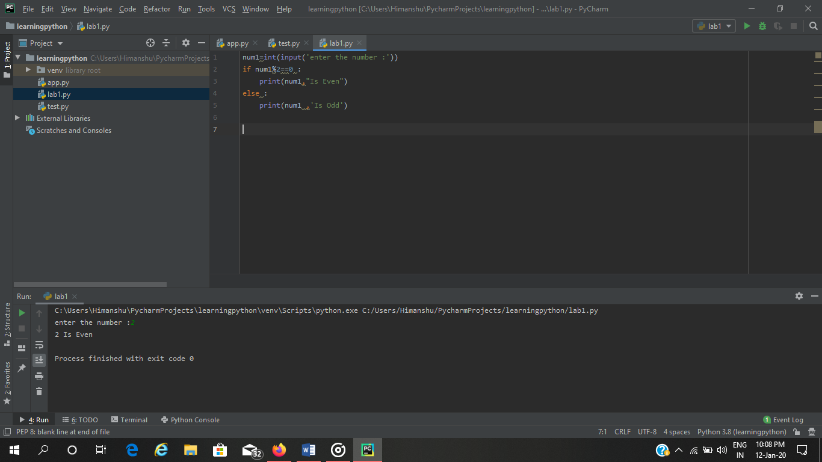

1. [**Check whether an entered year is leap year or not.**](https://www.programiz.com/python-programming/examples/prime-number)

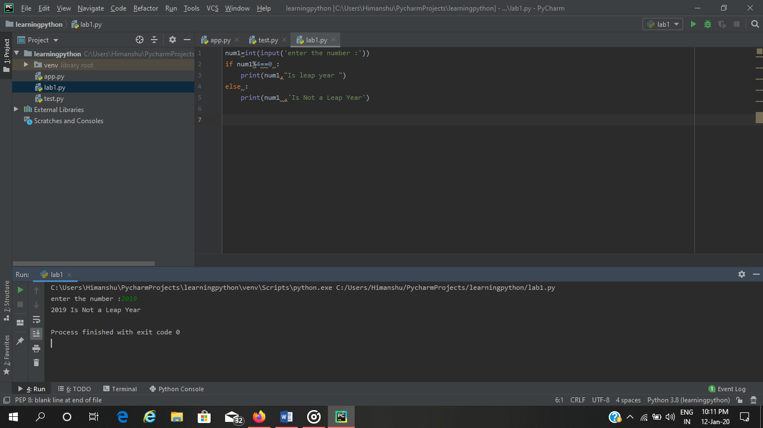

1. **Write a program to check whether a character is vowel or consonants**.

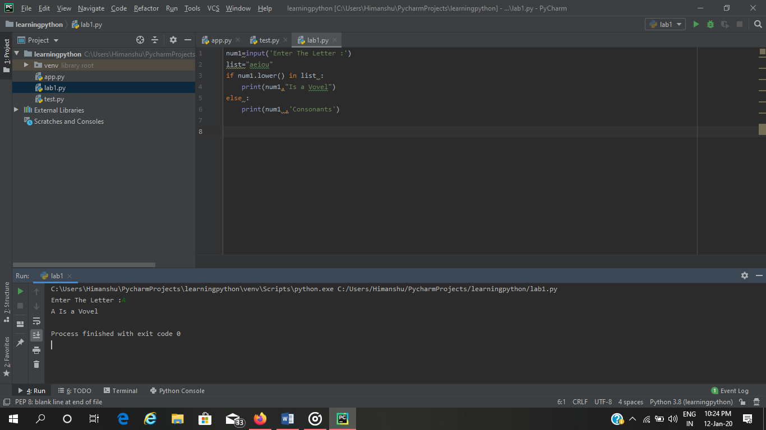

1. **Write a program to find the smallest of two numbers**.

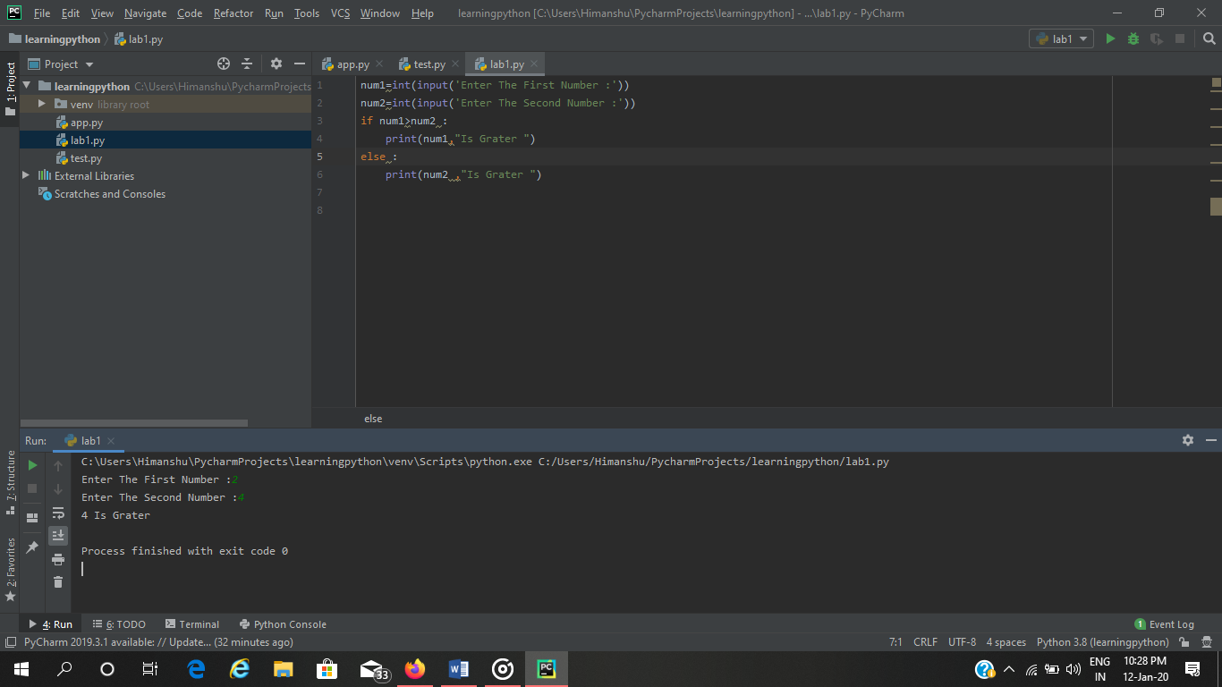

1. [**Find the Factorial of a Number**](https://www.programiz.com/python-programming/examples/factorial)

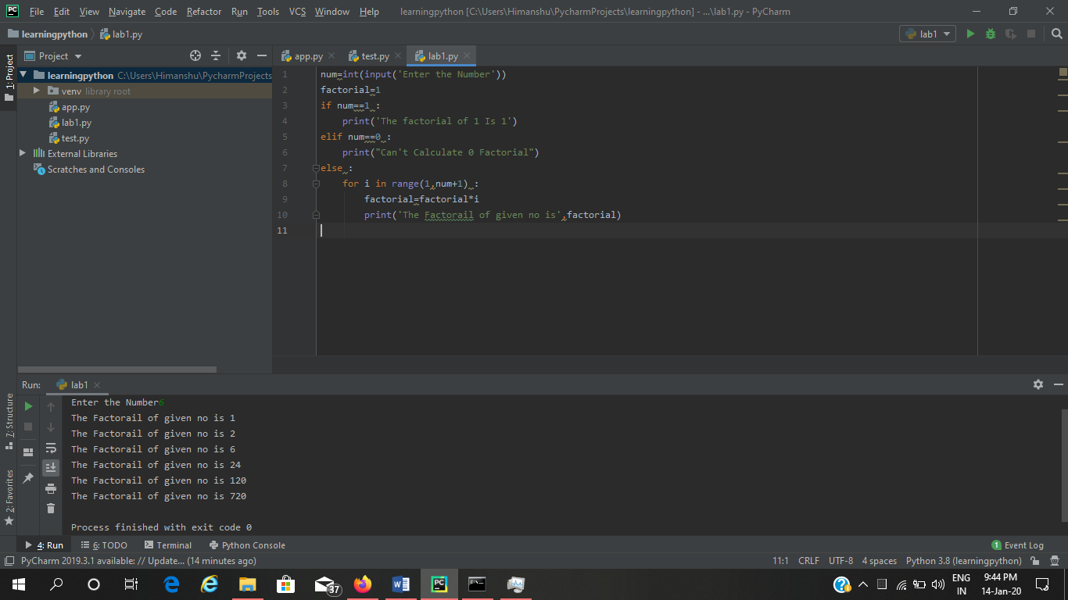

1. **Write a program to print this patterns**

**\***

**\* \***

**\* * \***

**\* * * \***

1. **Write a program to print this series**

**1 1 2 3 5 8 13**

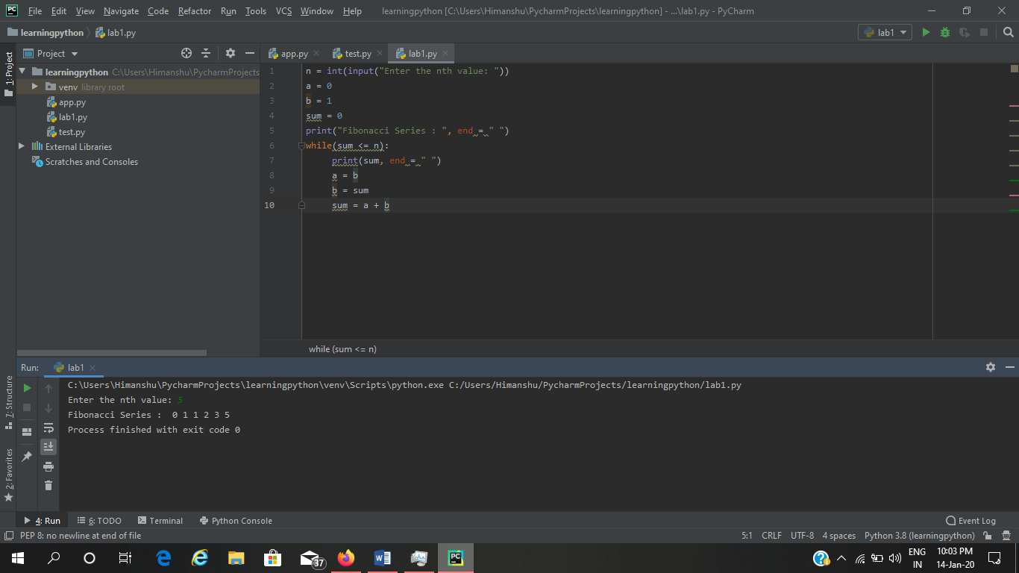

1. [**Check whether a number is prime or not**](https://www.programiz.com/python-programming/examples/prime-number)

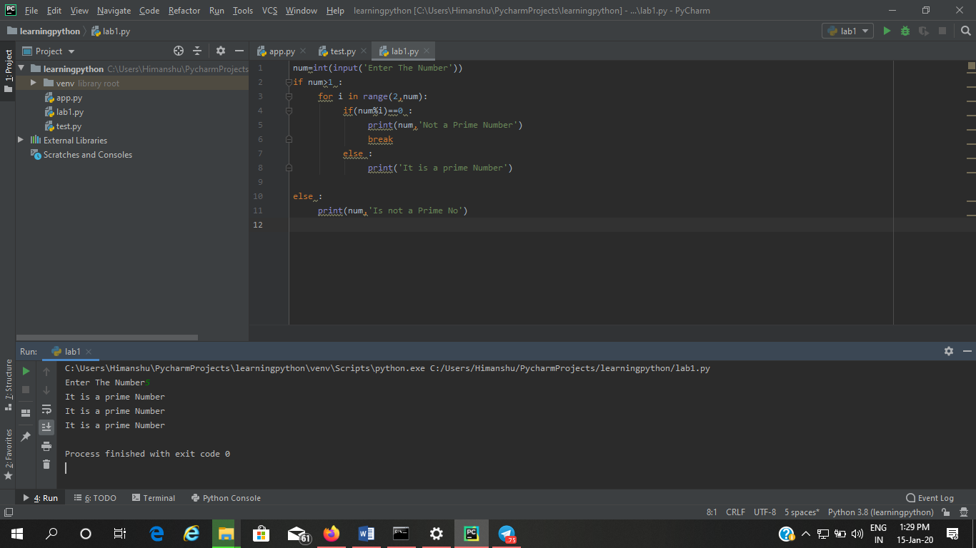

1. [**Make a Simple Calculator**](https://www.programiz.com/python-programming/examples/calculator)**.**

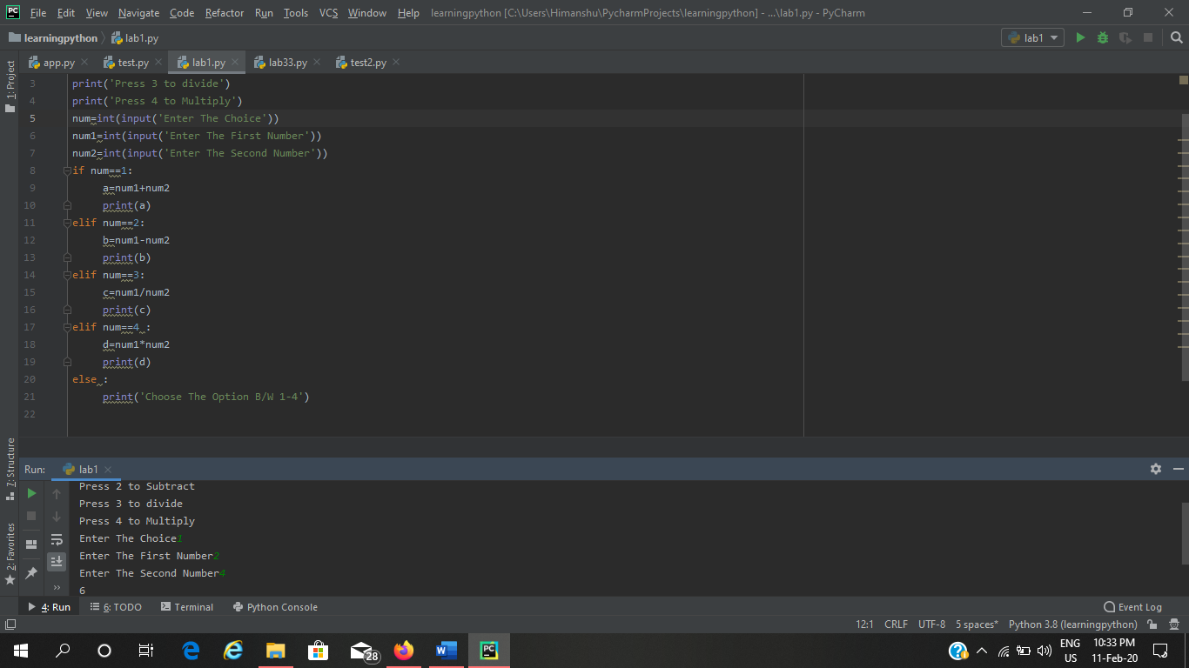

**TUPLE PYTHON LAB**

**Q1- Write a python program to create a tuple with different datatype**

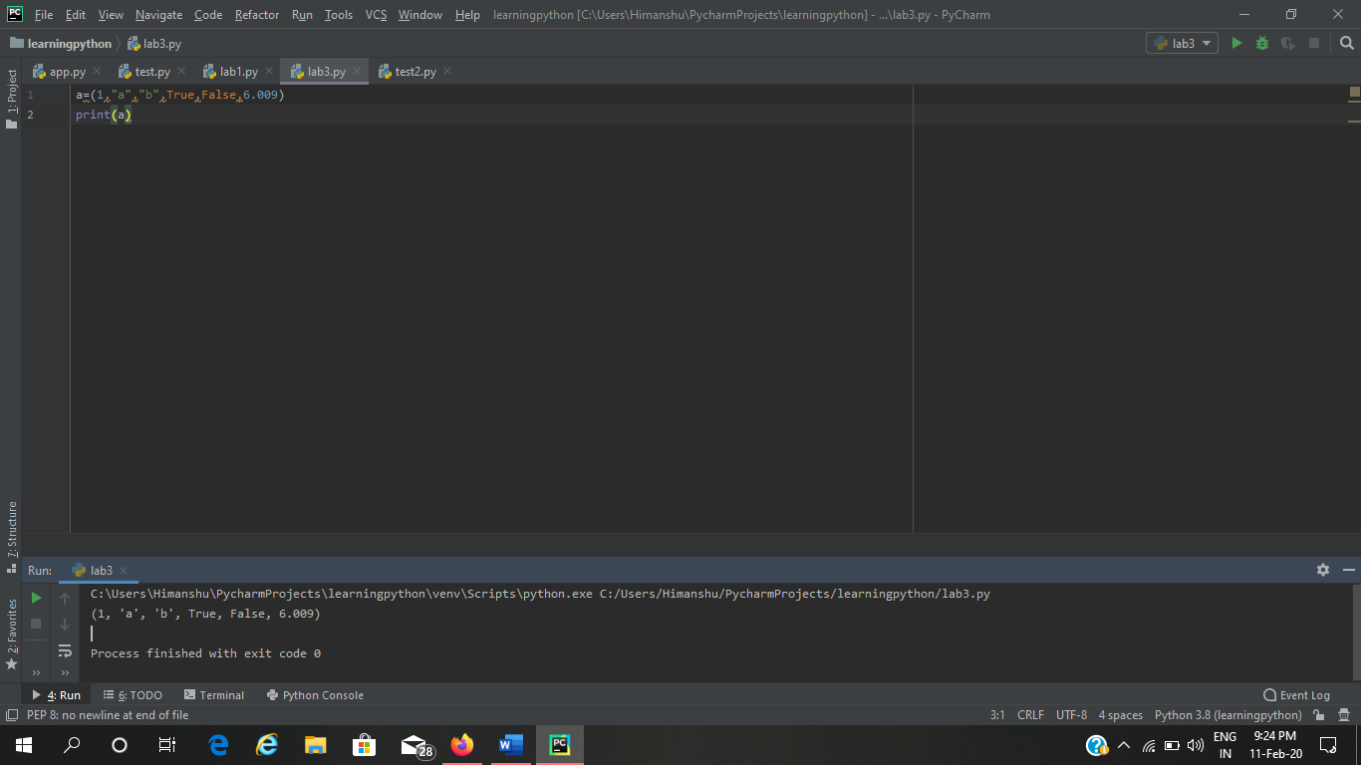

**Q2- write a python program to create a tuple and print 1 item ?**

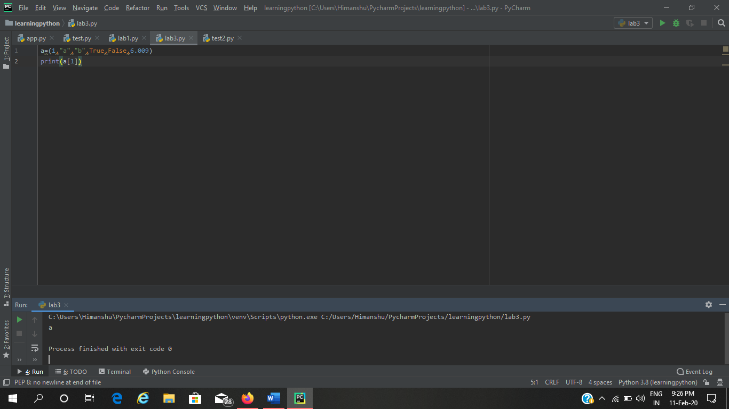

**Q3- Write a python program to create a unpack a tuple in several variables ?**

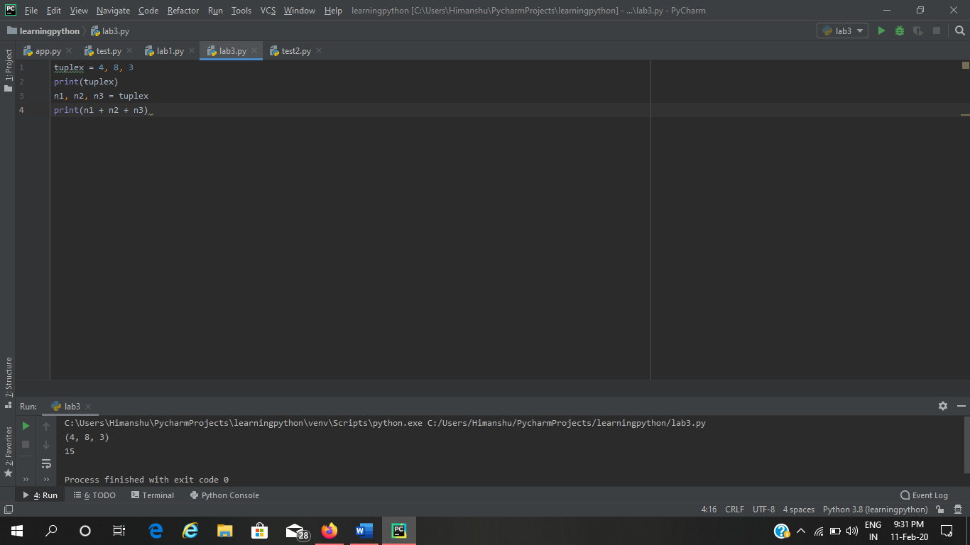

**Q4- Write a python program to add a item in tuple ?**

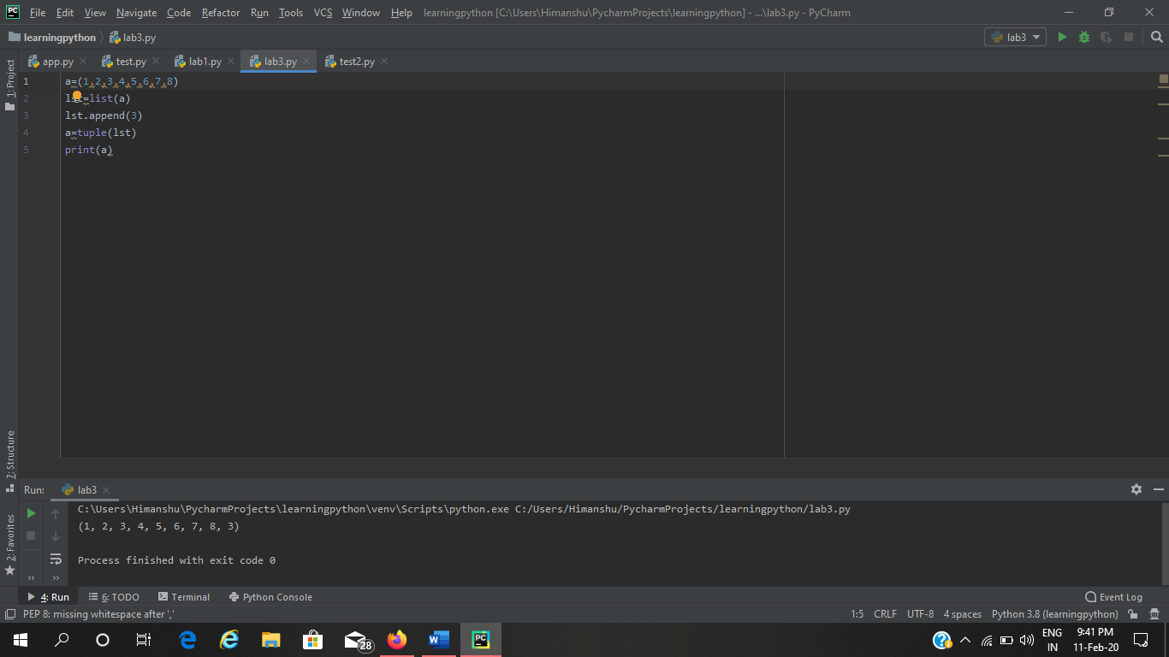

**Q5- Write a Python Program to covert a Tuple into a String**

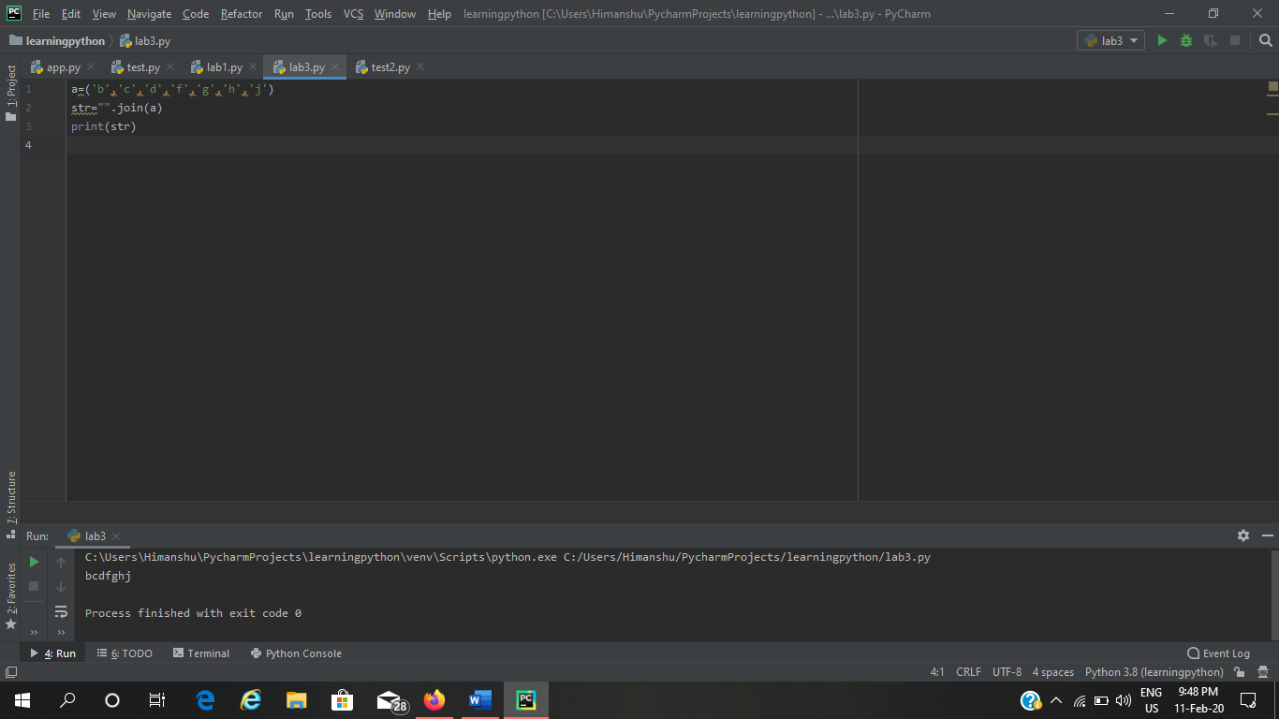

**Q6- Write a python program to get the 4th element and 4th Element from the last of the tuple ?**

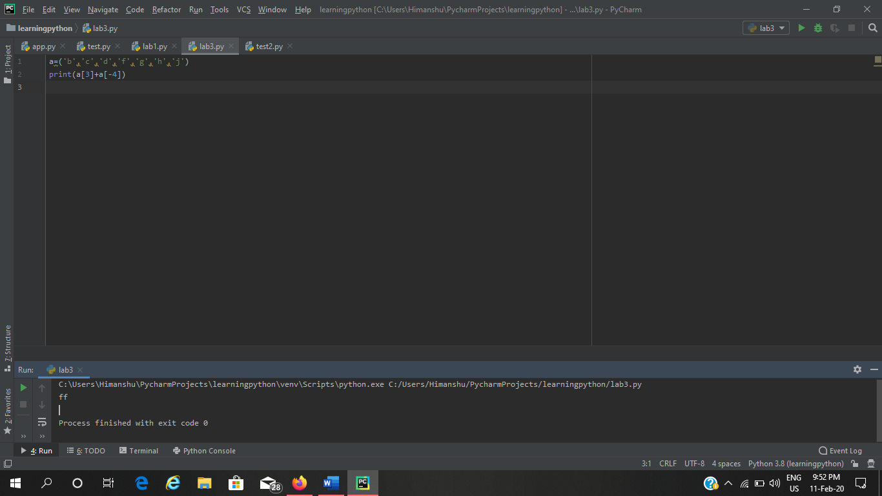

**Q7 – Write a Python Program to clone a Tuple**

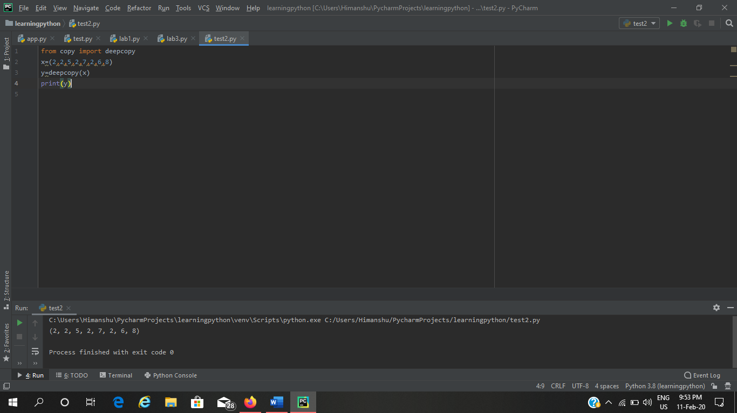

**Q8- Write a python program to find repeat item in tuple ?**

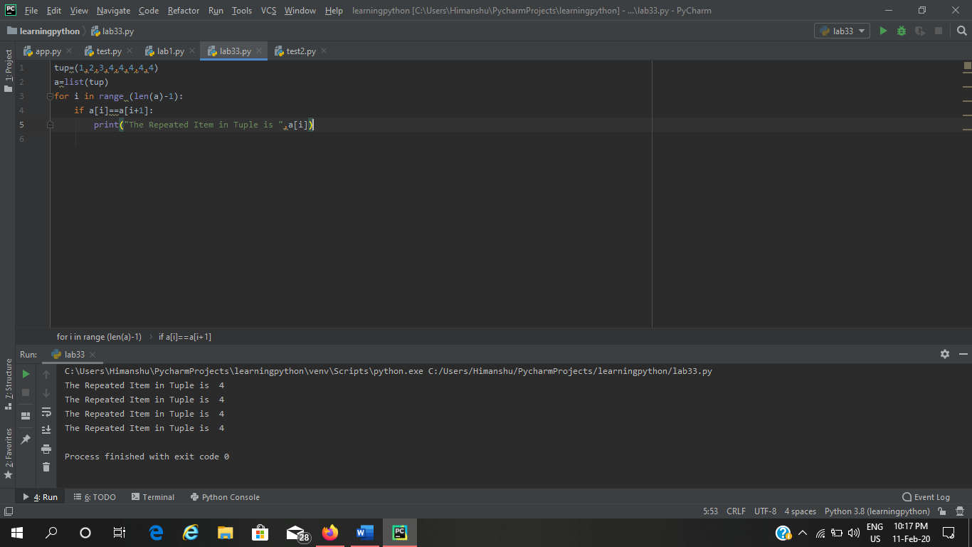

**Q9- Write a Python Program check Whether an Element exists Within a tuple ?**

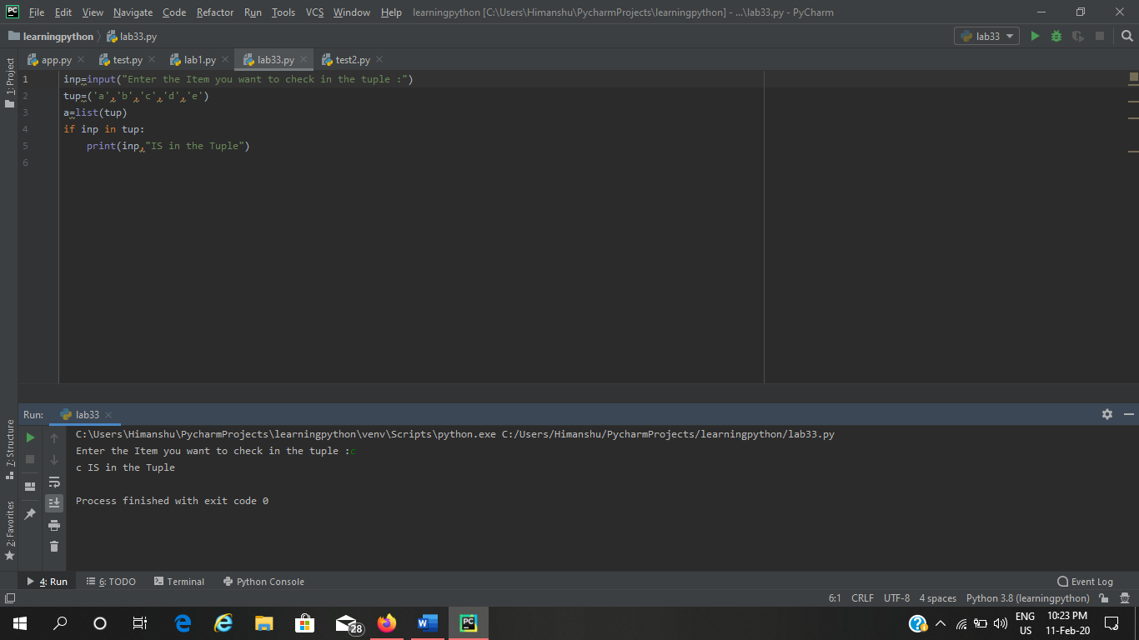

**Q10- Write a python program to convert list to a tuple?**

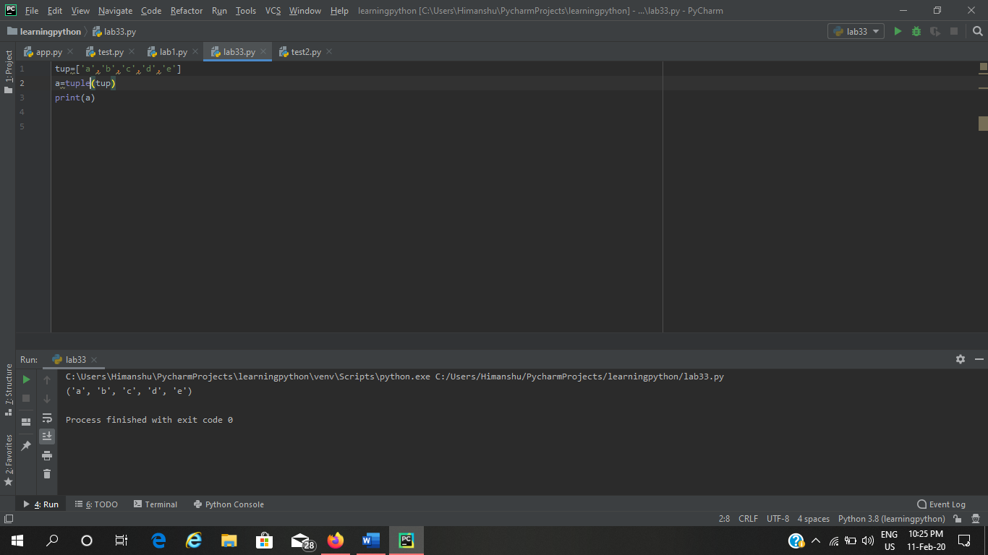

**Q-11 Write a Python program to remove a item from tuple ?**

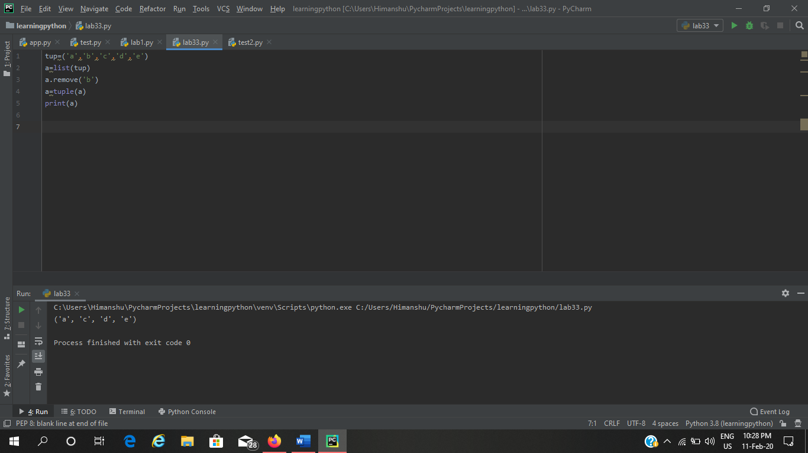

**LIST LAB PYTHON**

**Q1**

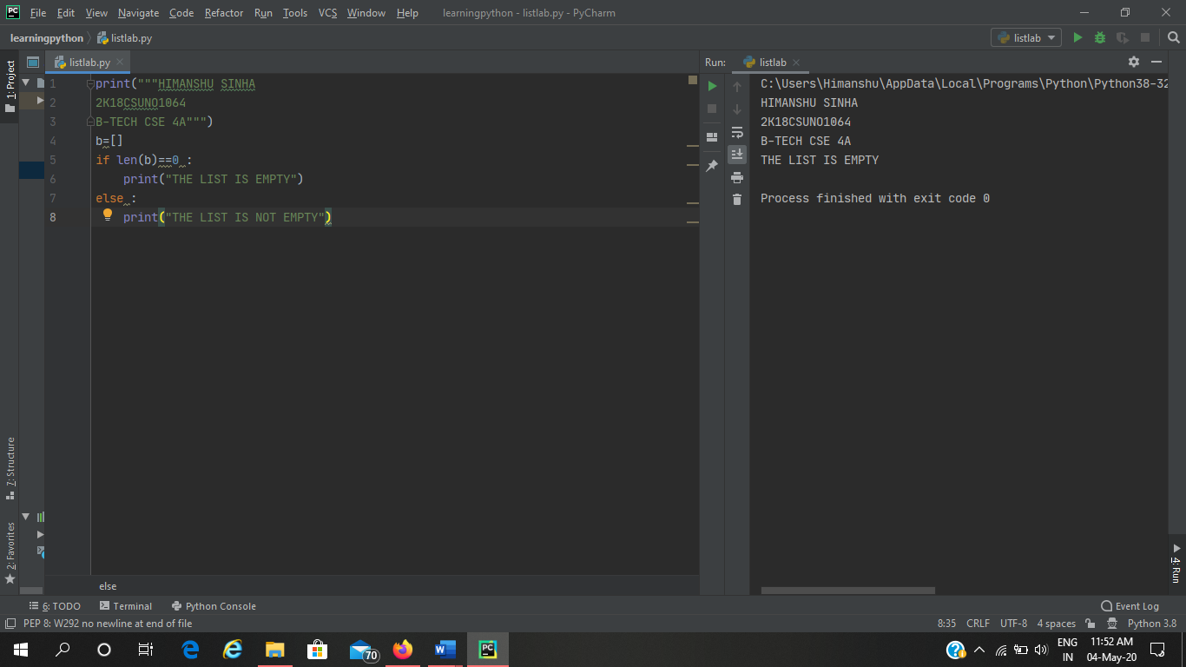

**Q2**

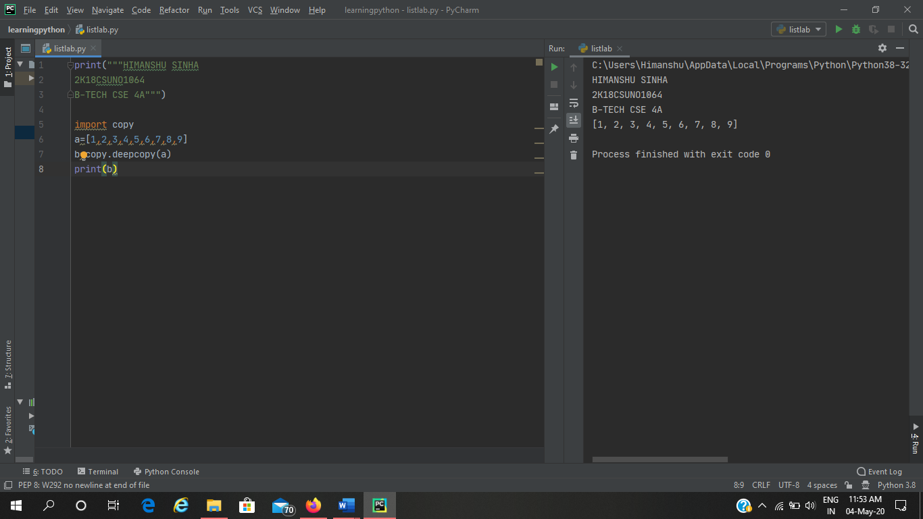

**INHERITANCE IN PYTHON**

1. **Write a Python program that has a class Animal with a method legs(). Create two subclasses Tiger and Dog, access the method leg explicitly with class Dog and implicitly with the class Tiger.**

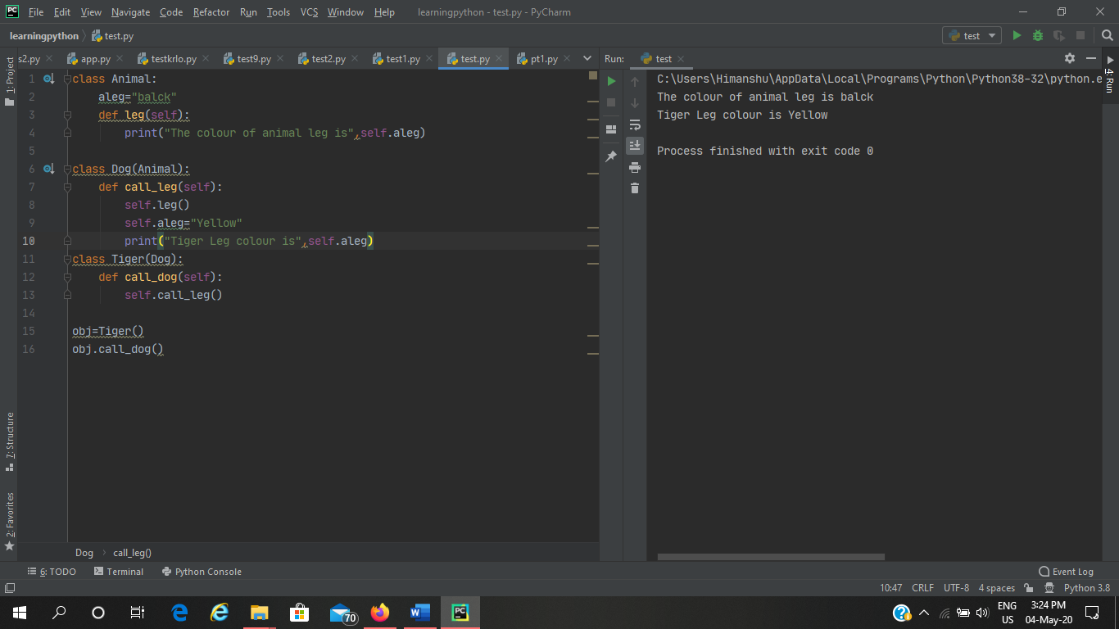

1. **Write a Python program to create a class Employee. Define two subclasses: Engineer and Manager. Every class should have method named printDesignation() that prints Engineer for Engineer class and Manager for Manager Class.**

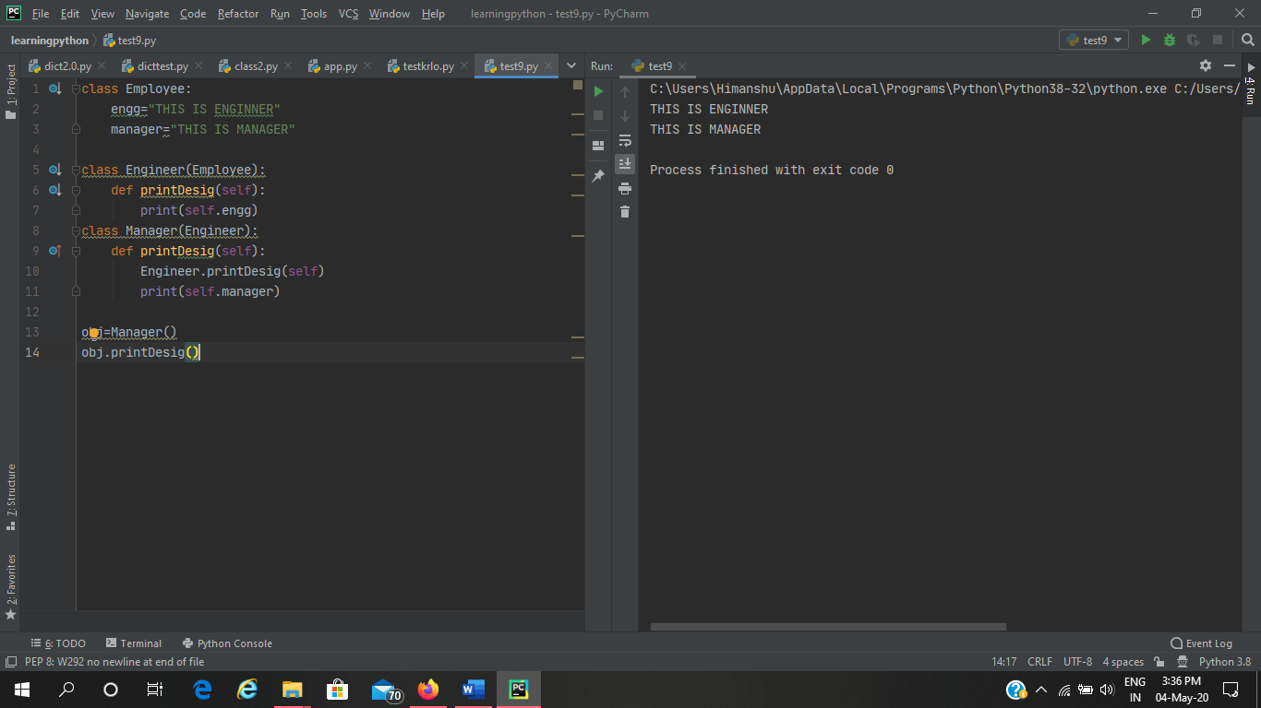

1. **Write a Python program to demonstrate classes and their attributes.**

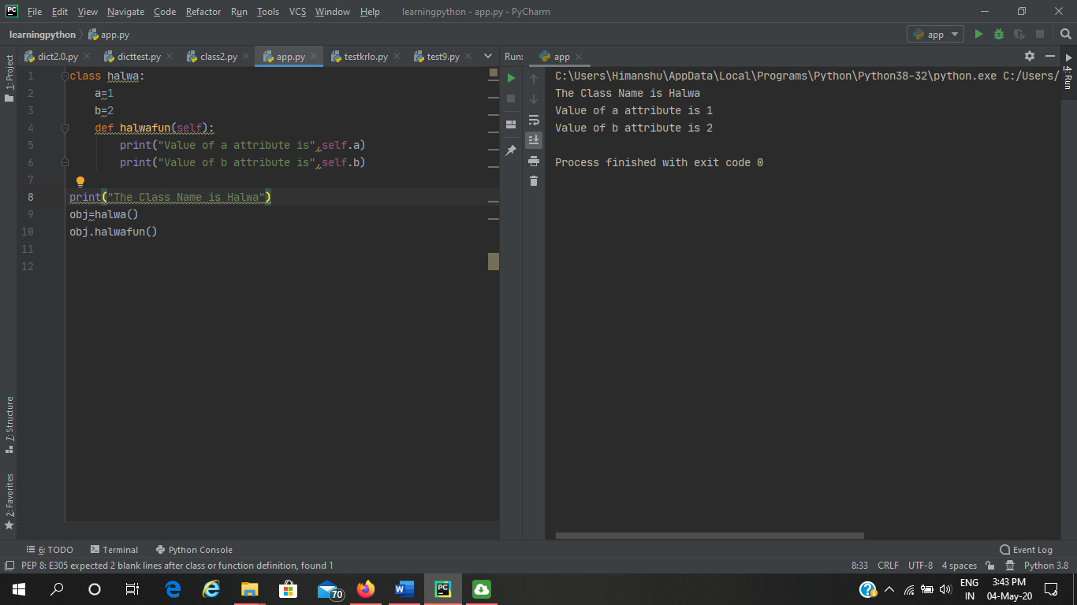

1. **Write a Python program to demonstrate Inheritance and method overriding.**

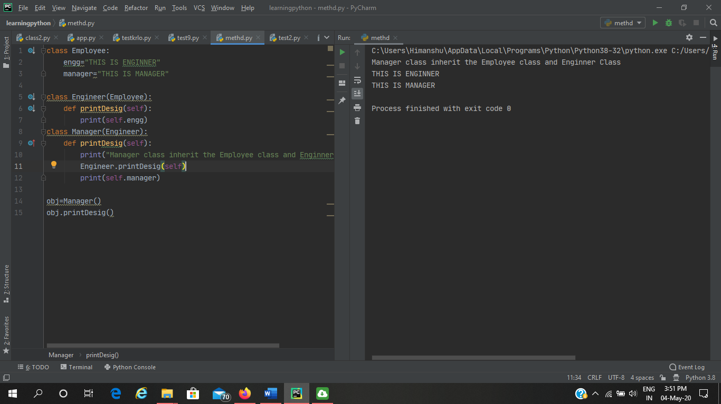

1. **Write a Python program to demonstrate multiple Inheritance.**

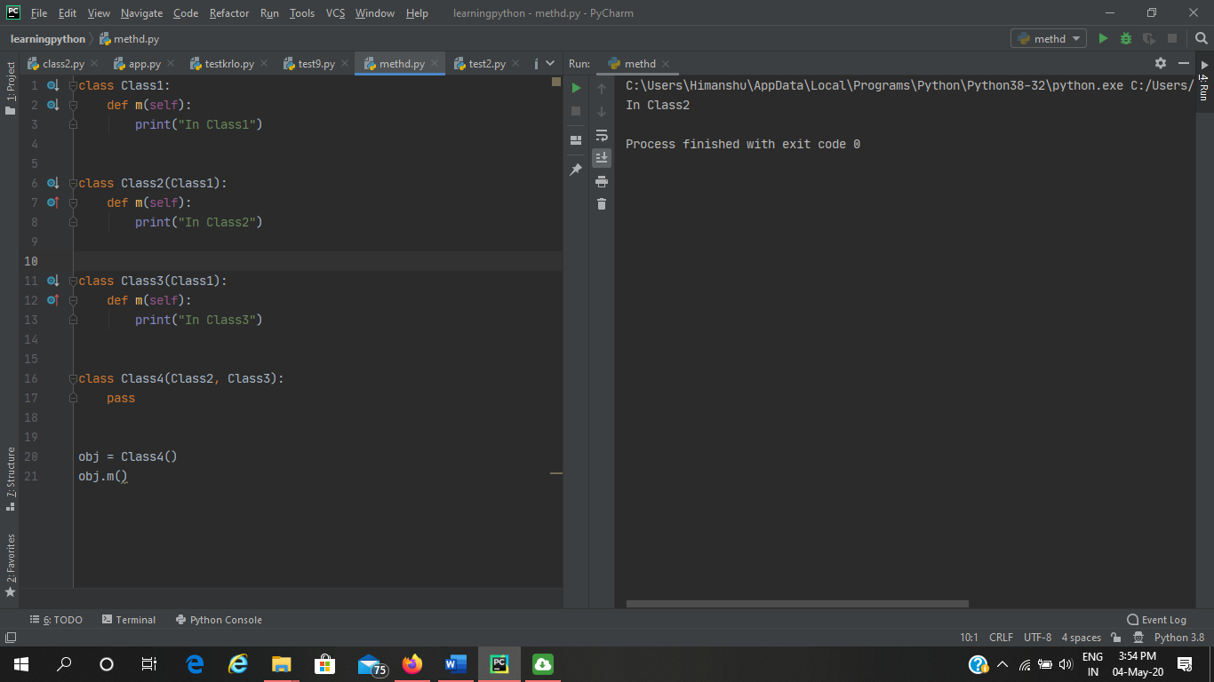

**Q3**

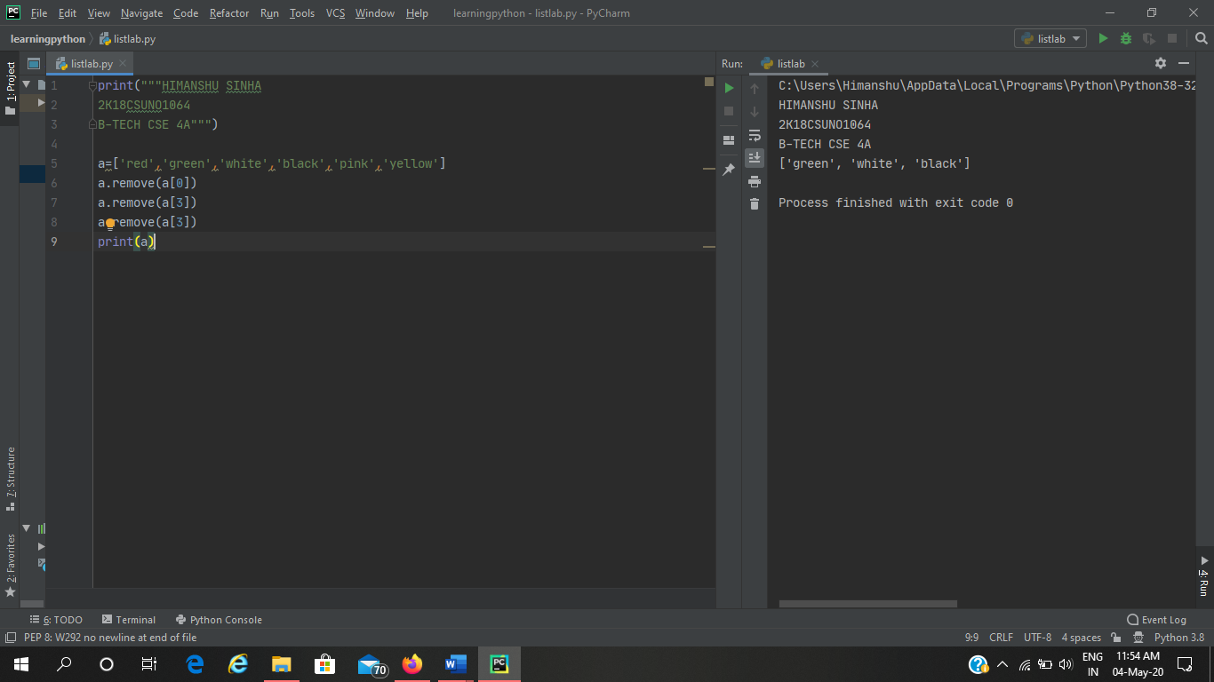

**Q4**

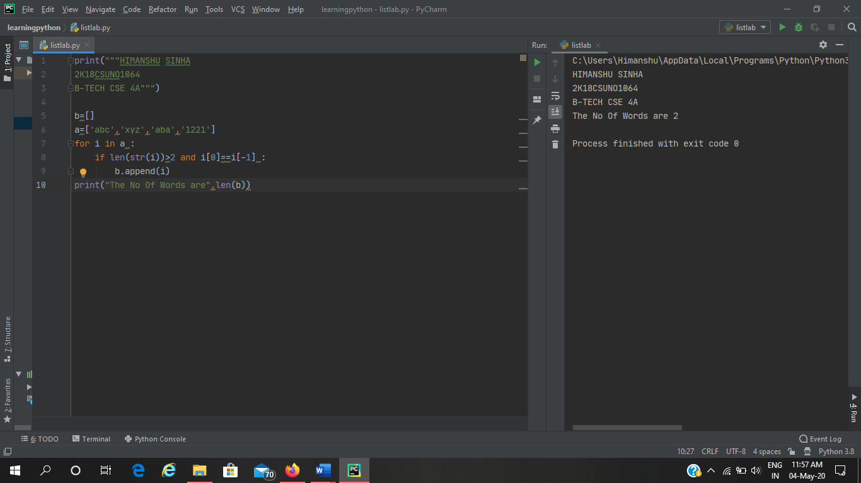

**Q5**

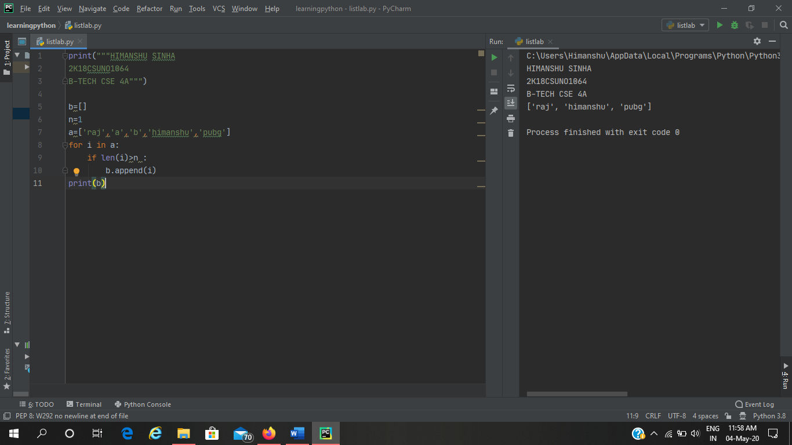

**Q6**

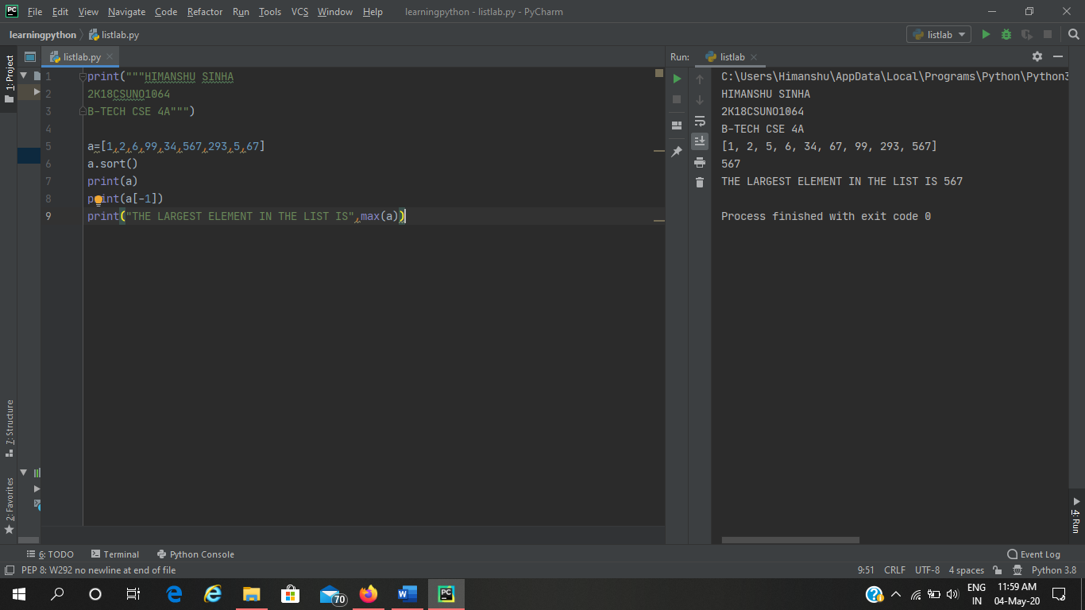

**Q7**

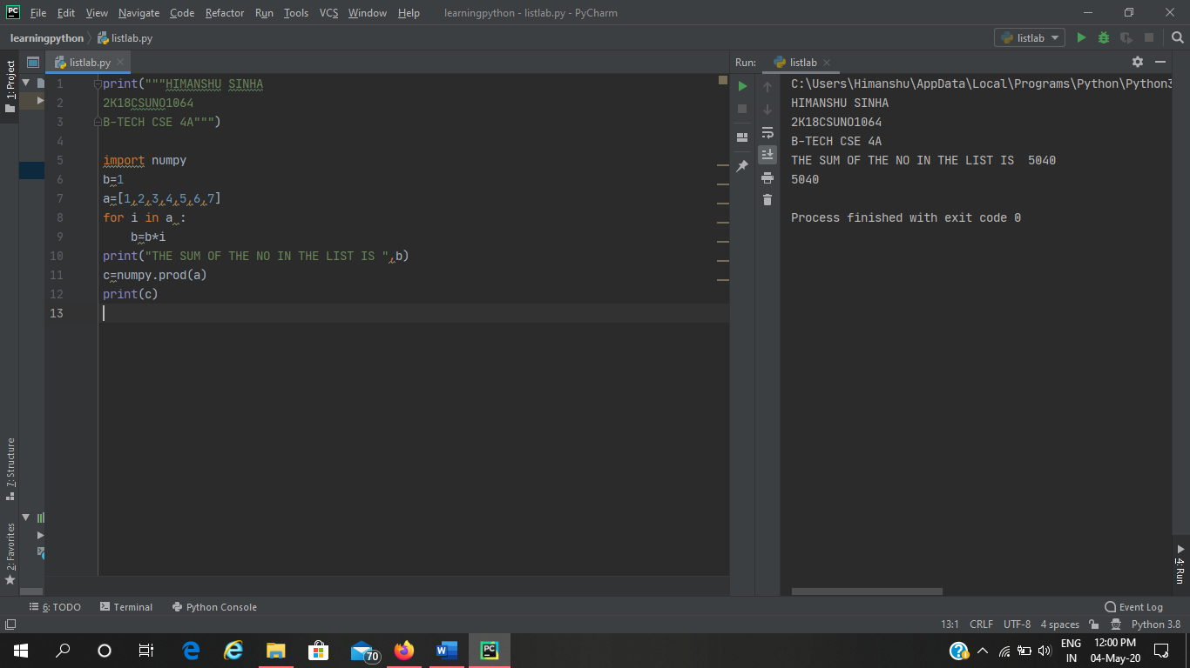

**Q8**

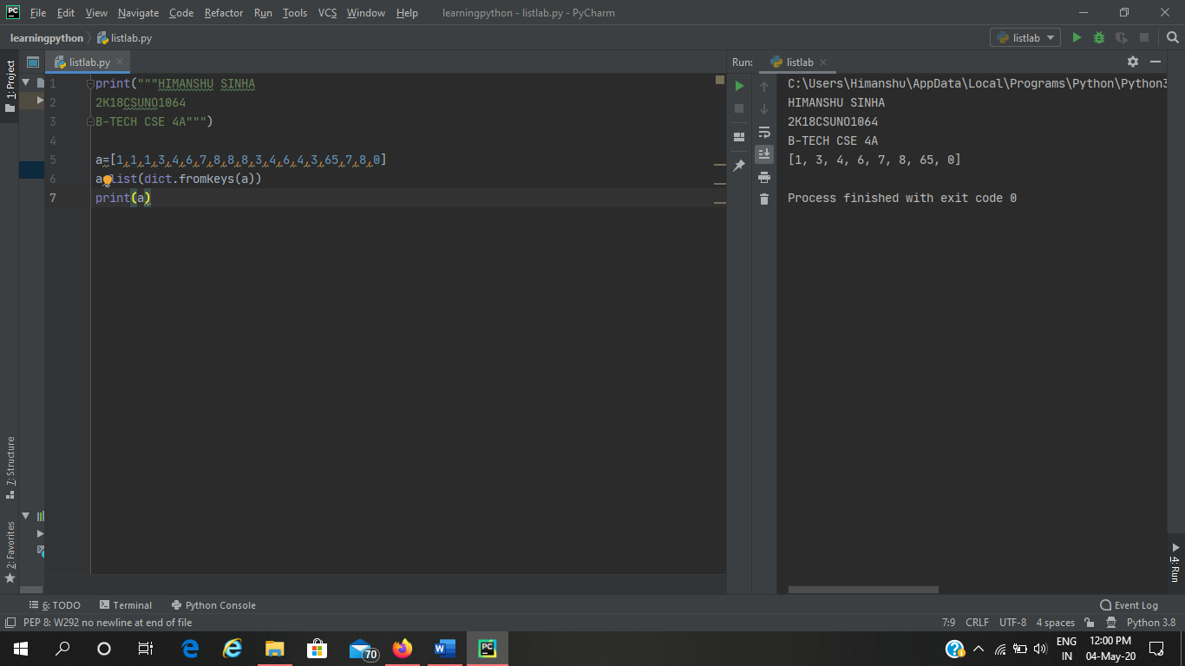

**Q9**

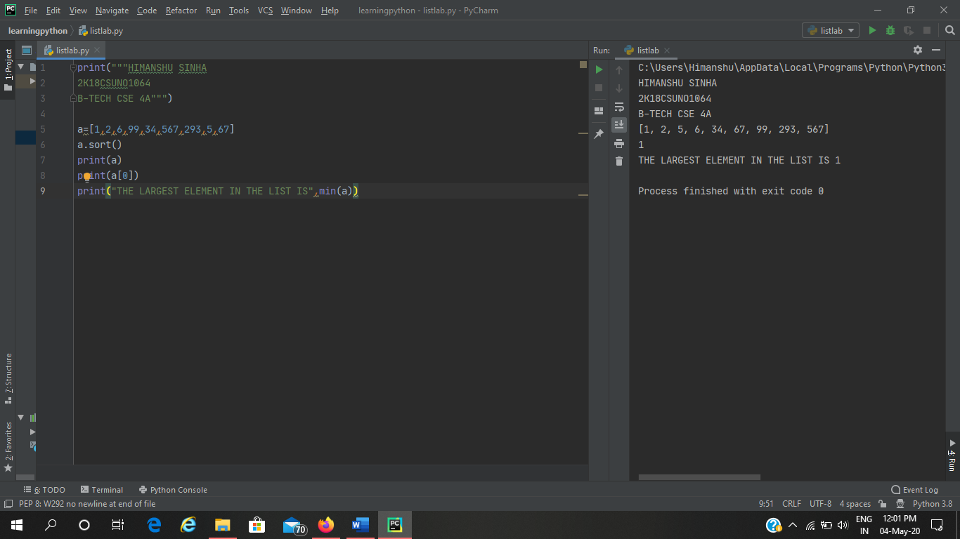

**Q10**

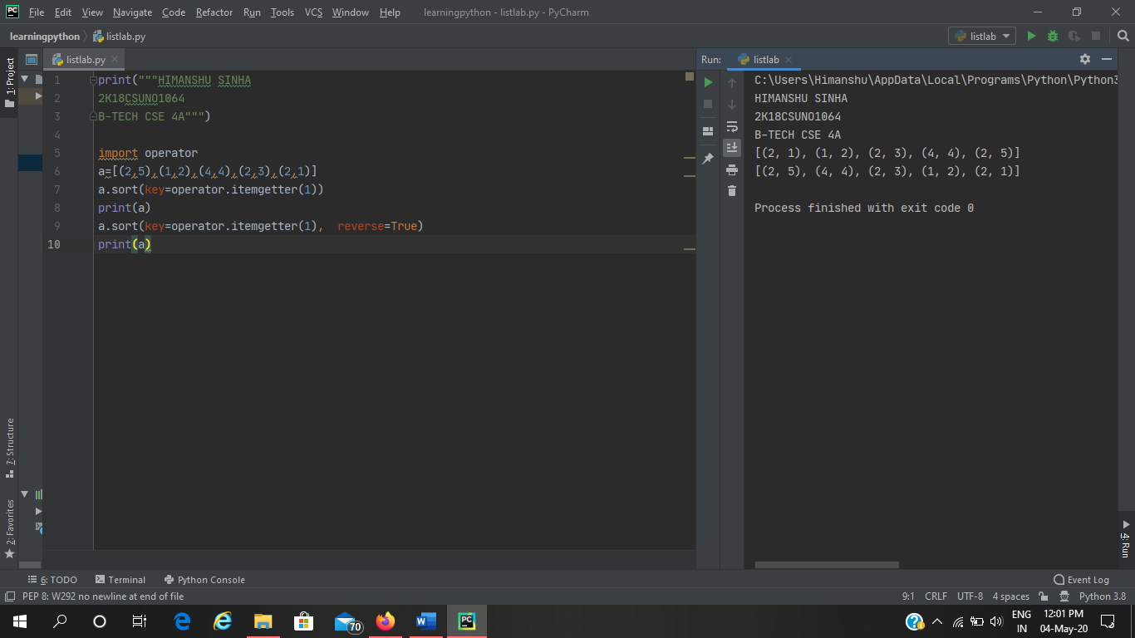

**Q11**

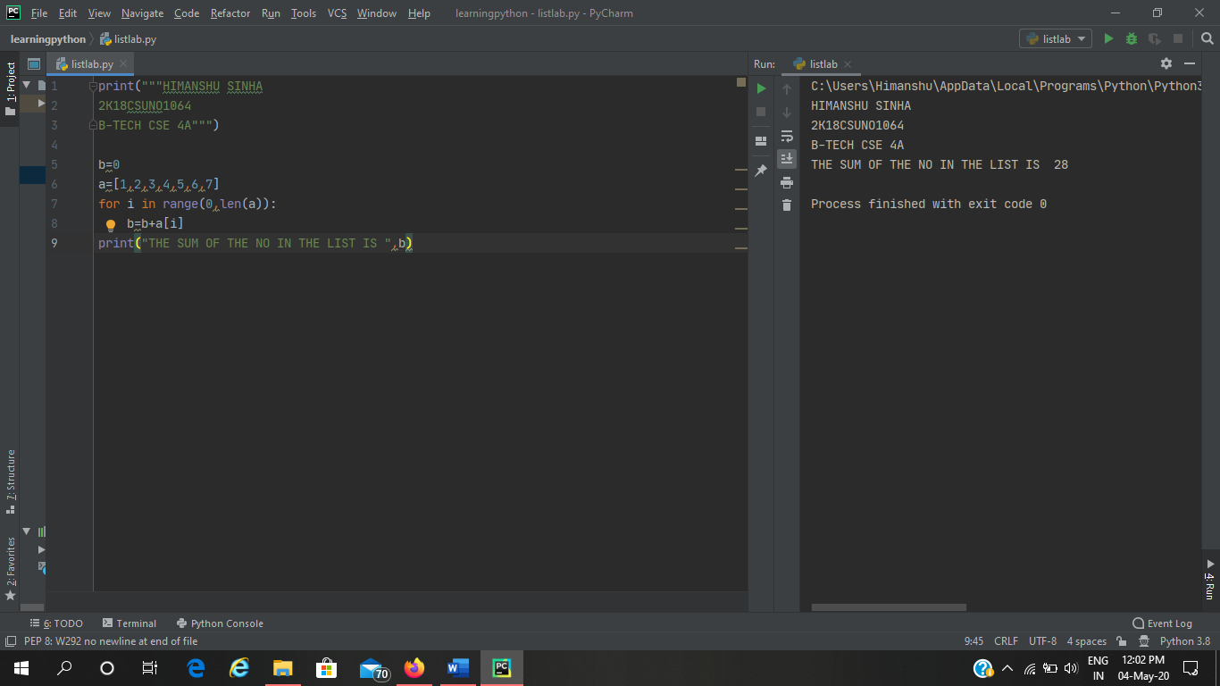

**Q12**

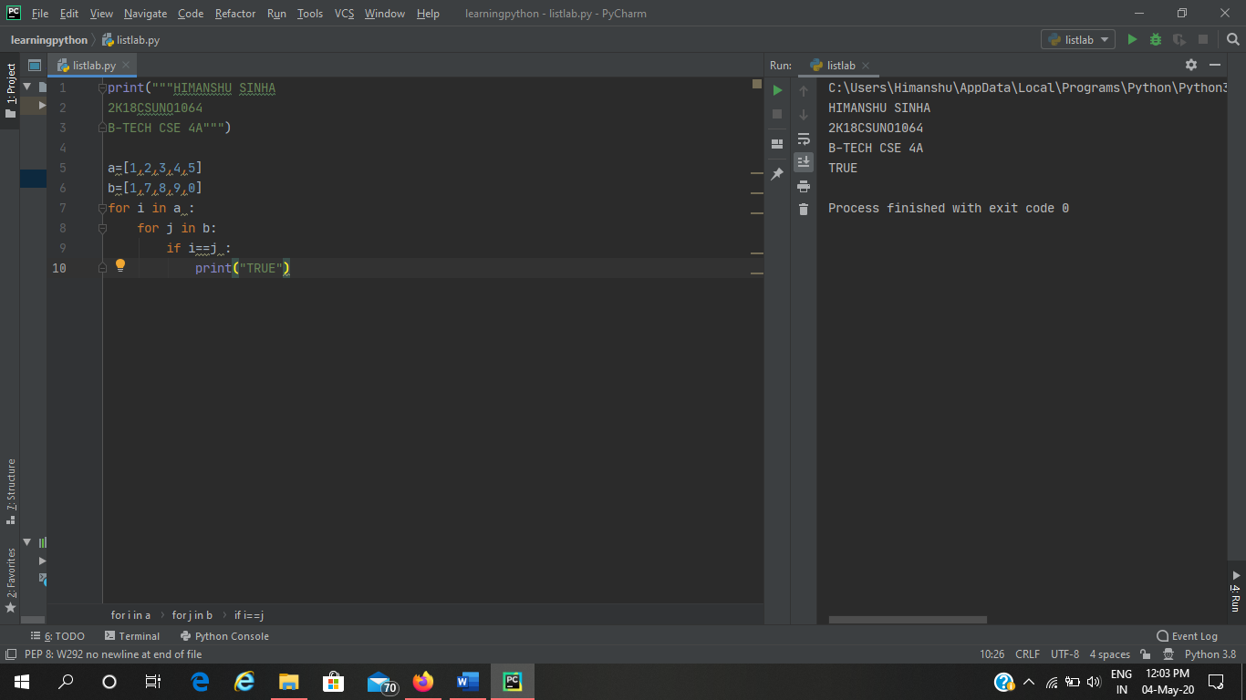

**Dictionary**

1. **Create an empty dictionary**

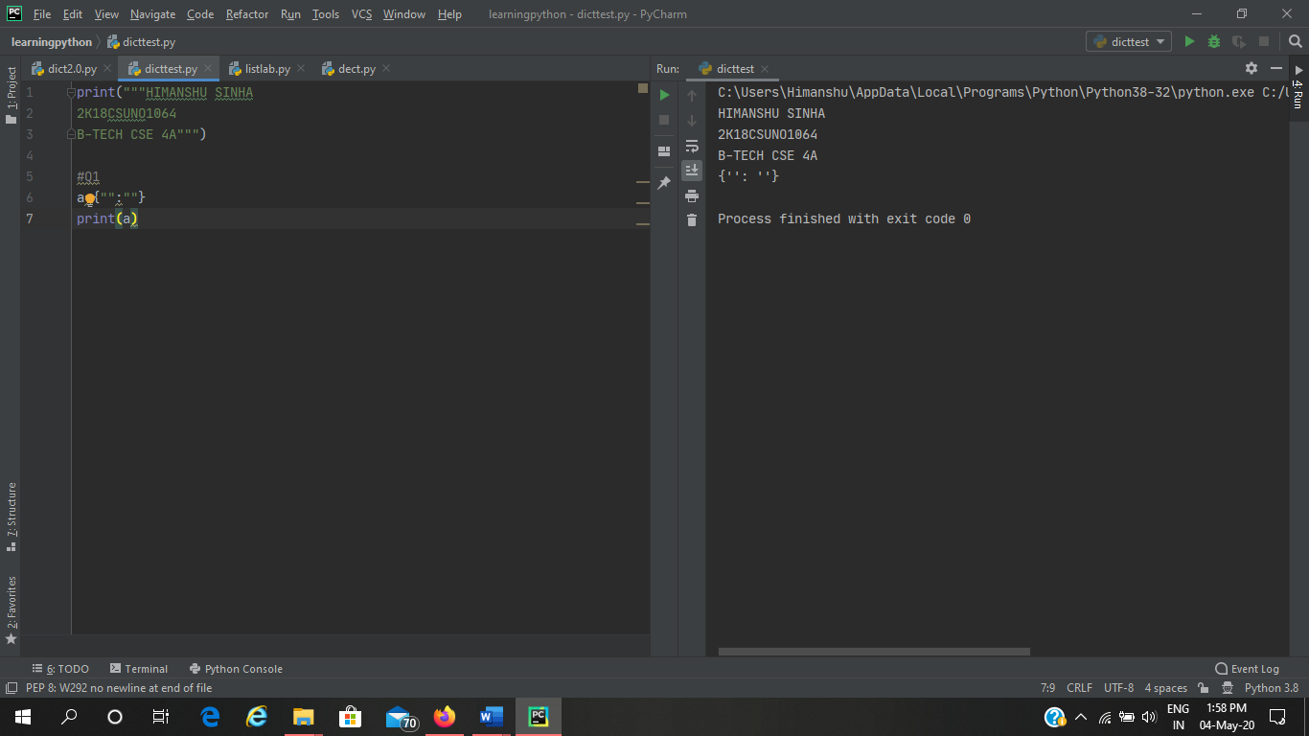

1. **Create the following dictionary** 
   1. **Key value**
   2. **A 10**
   3. **B 20**

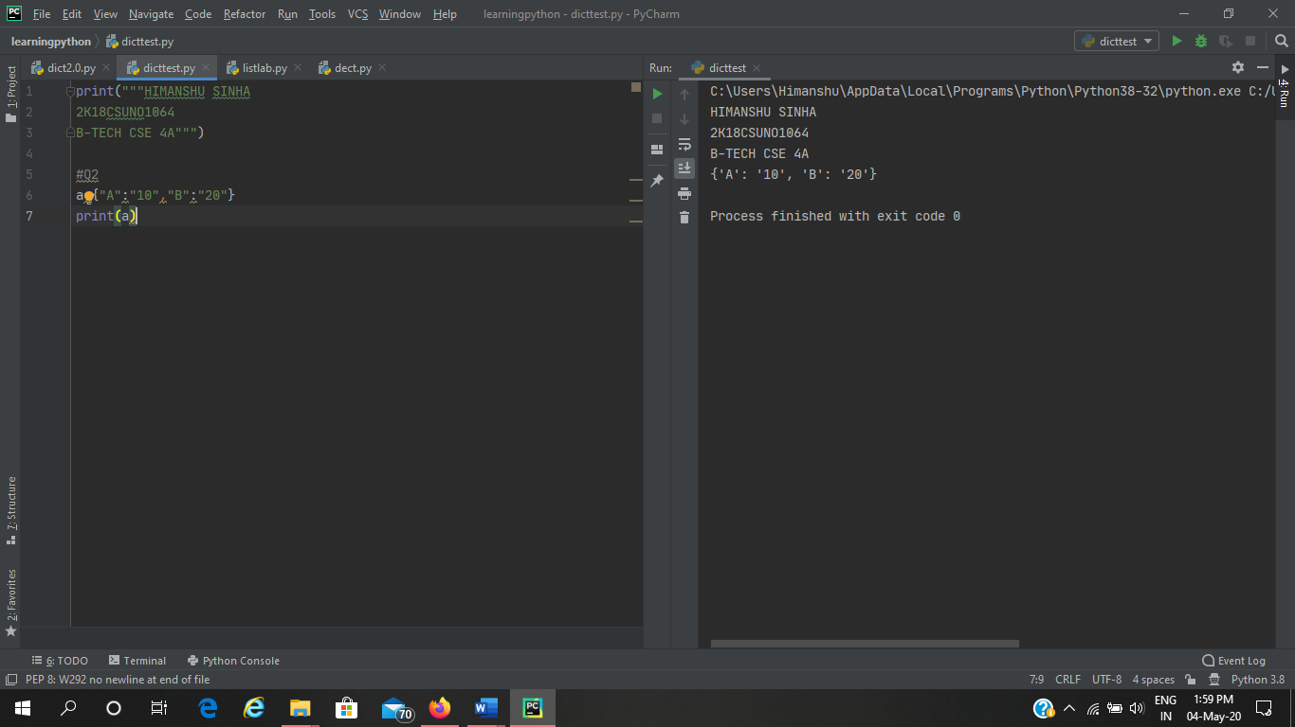

1. **Create a dictionary with different datatypes for keys**

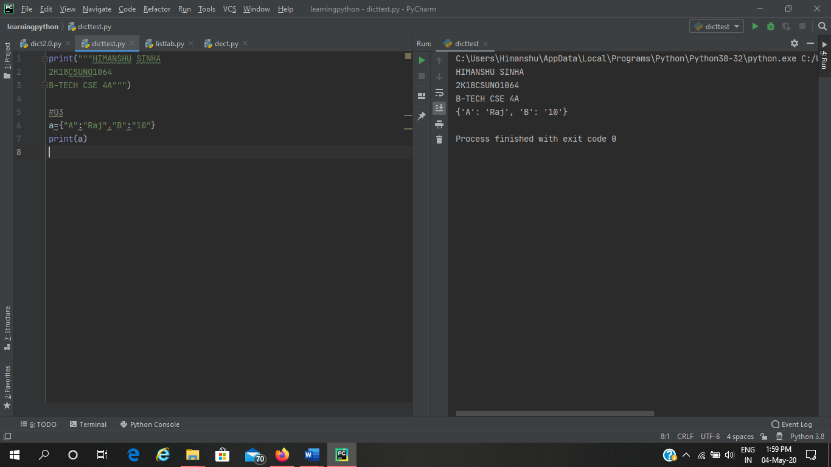

1. **Print all the items of a dictionary**

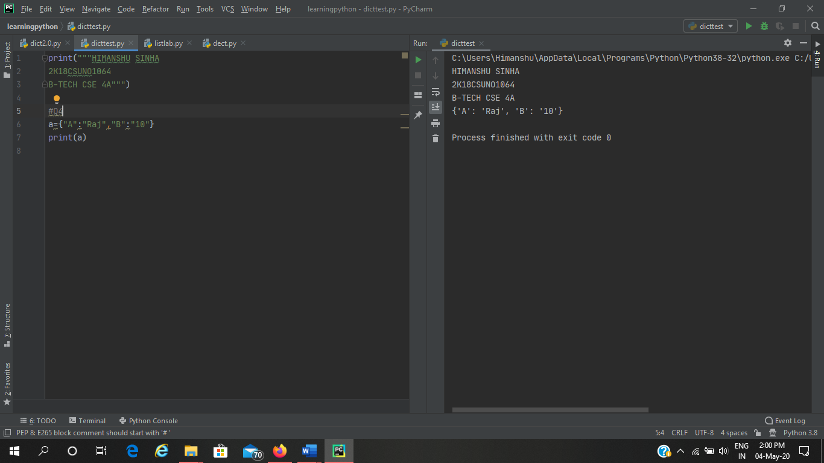

1. **Delete an element of a dictionary**

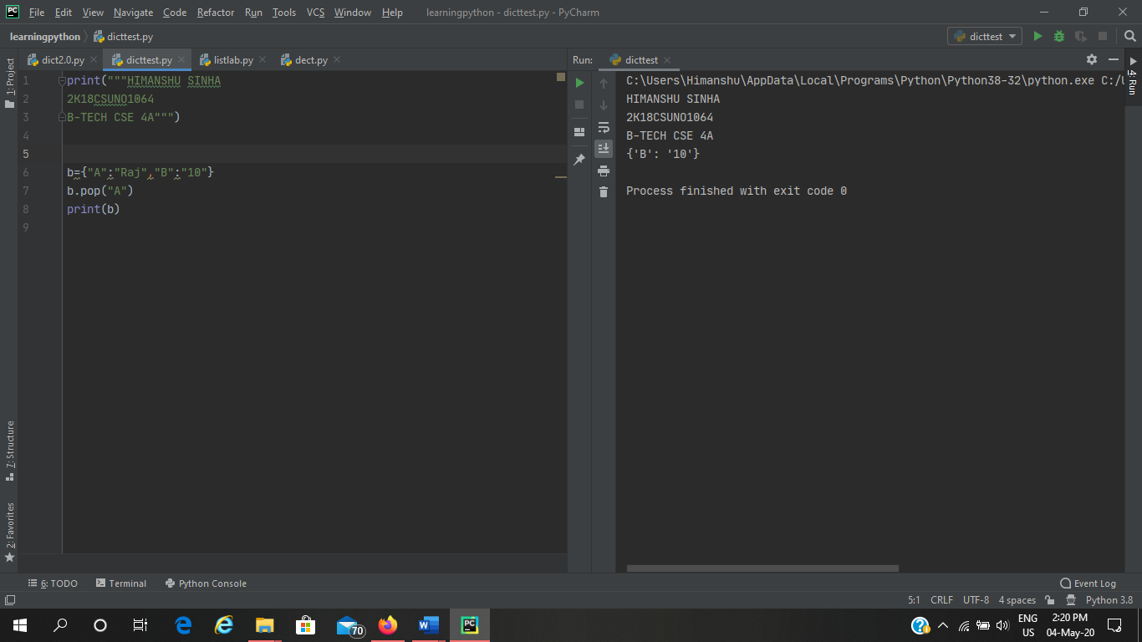

1. **Delete full dictionary**

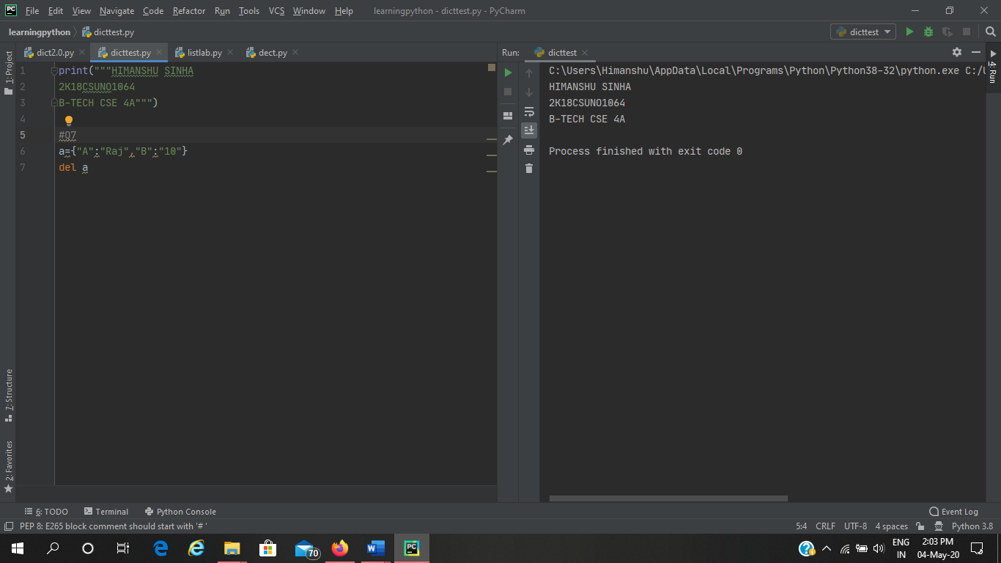

1. **Print a value for a key**

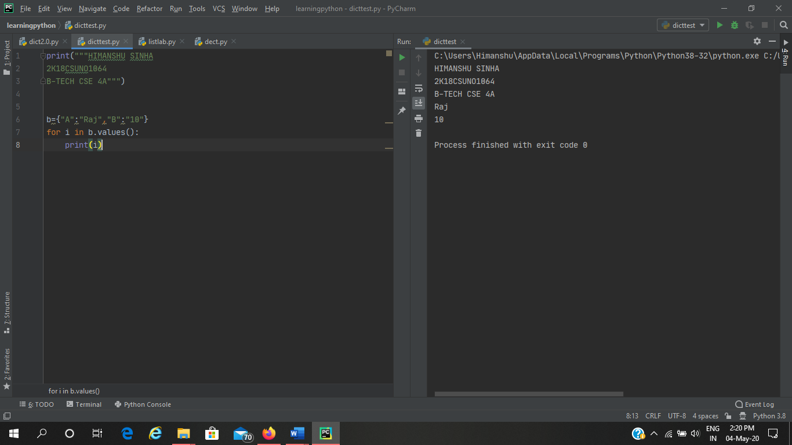

1. **To check if a key id present in a dictionary**

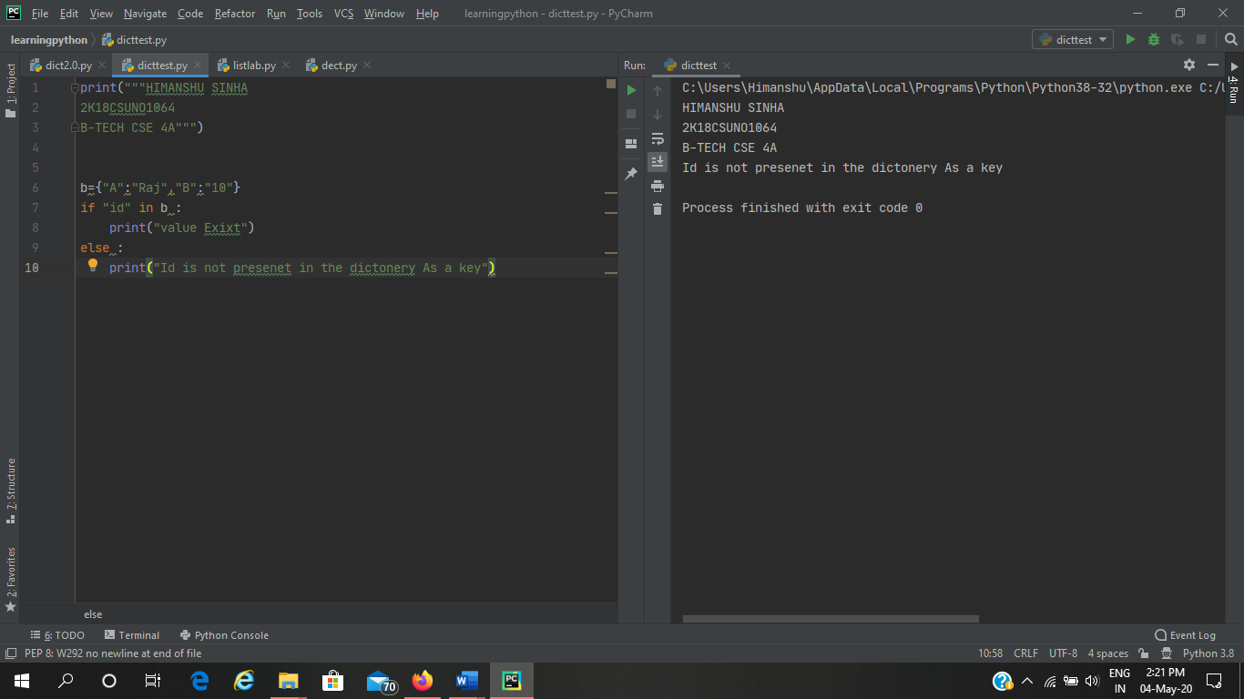

1. **Update a value of a key**

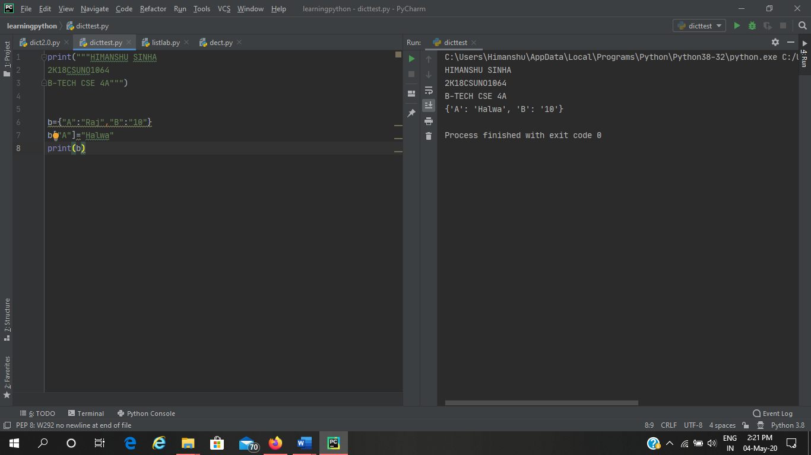

1. **Add a new key value pair**

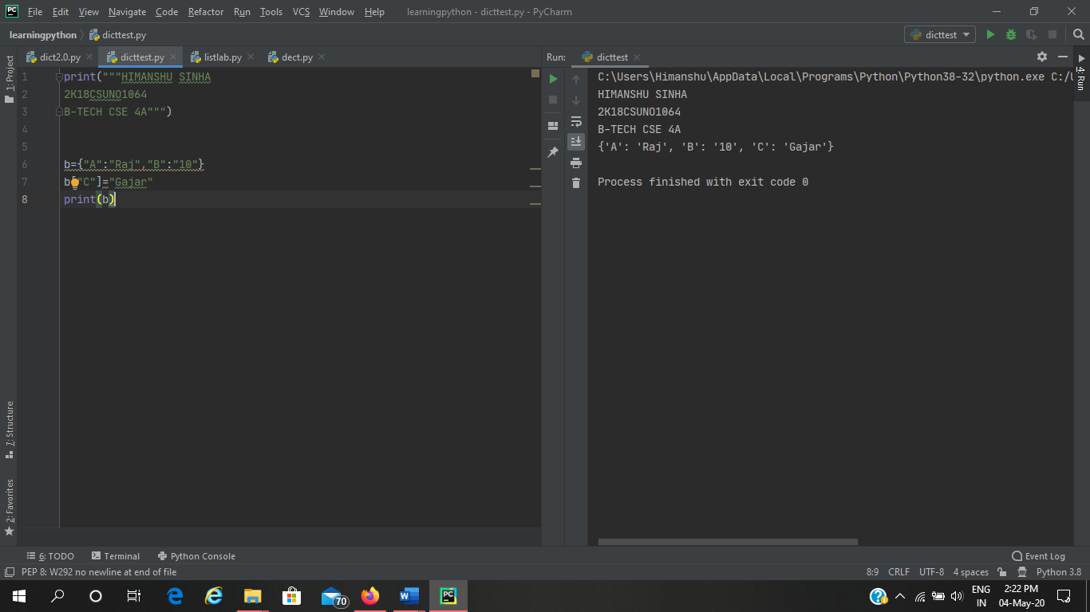

1. **Print dictionary for keys{1,10} and values as square of keys**

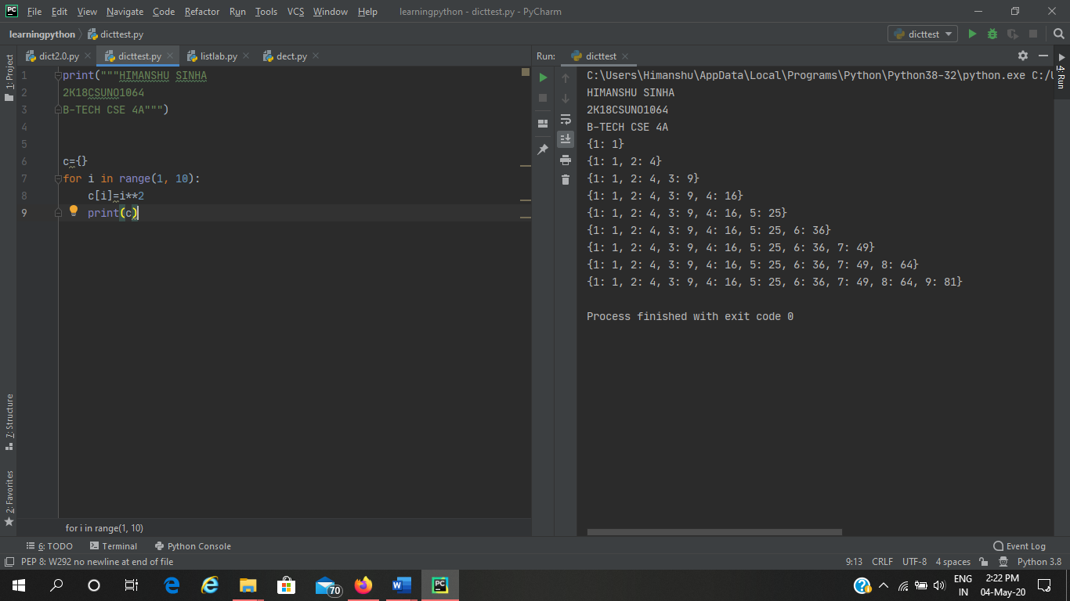

1. **Print nested dictionary**

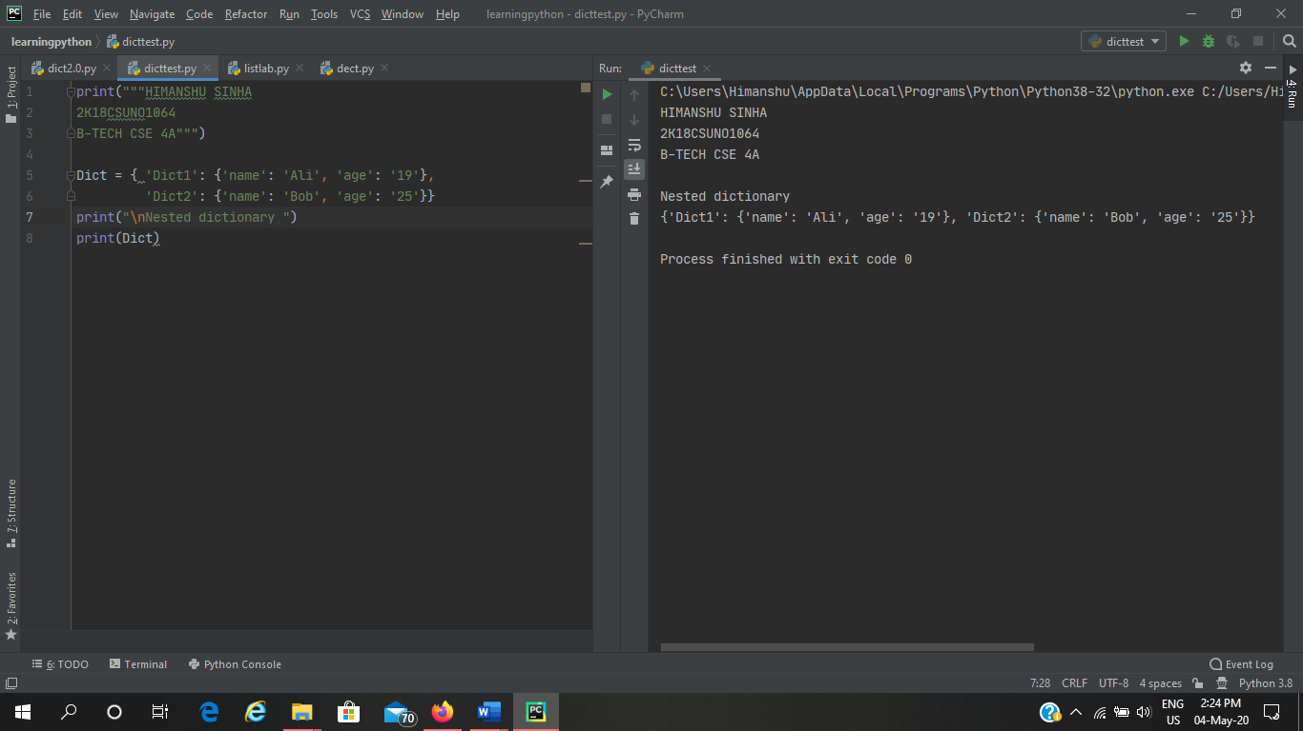

1. **Concatenate three dictionaries**

**Sample Dictionary :  
dic1={1:10, 2:20}  
dic2={3:30, 4:40}  
dic3={5:50,6:60}  
Expected Result : {1: 10, 2: 20, 3: 30, 4: 40, 5: 50, 6: 60}**

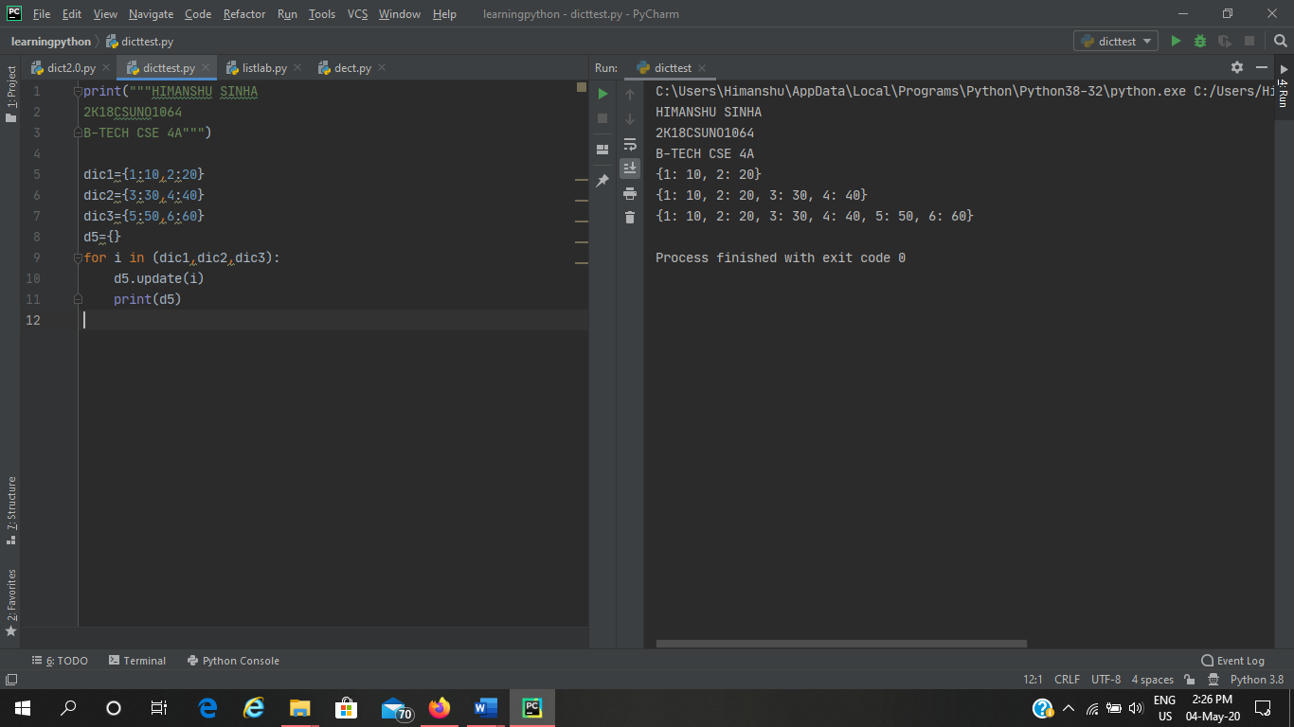

1. **Sum all the values of a dictionary**

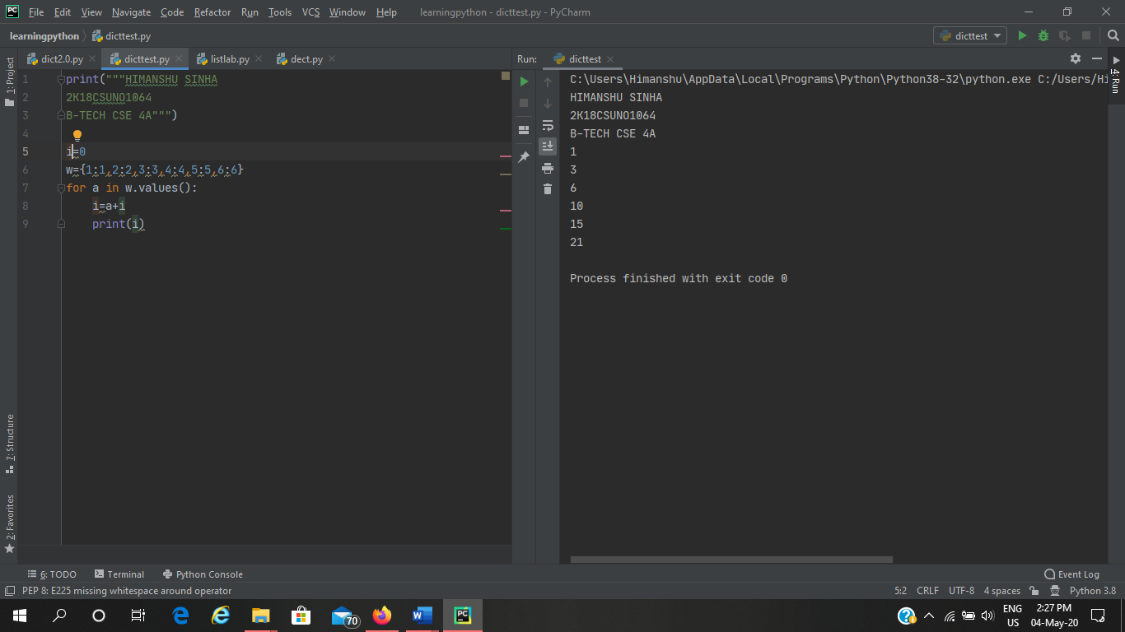

1. **Accessing an element of a nested dictionary**



1. **Write a Python script to print a dictionary where the keys are numbers between 1 and 15 (both included) and the values are square of keys.**

**Sample Dictionary  
{1: 1, 2: 4, 3: 9, 4: 16, 5: 25, 6: 36, 7: 49, 8: 64, 9: 81, 10: 100, 11: 121, 12: 144, 13: 169, 14: 196, 15: 225}**

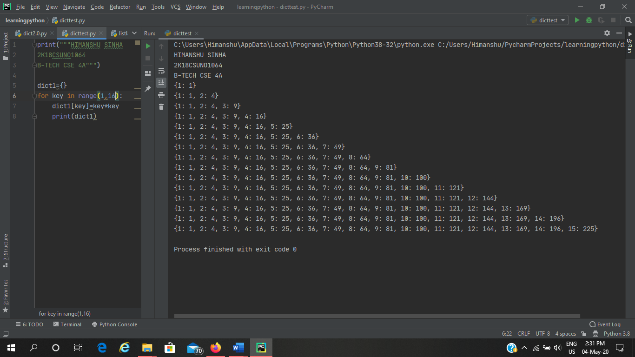

1. **Insert factorial of keys in values. And print dictionary**

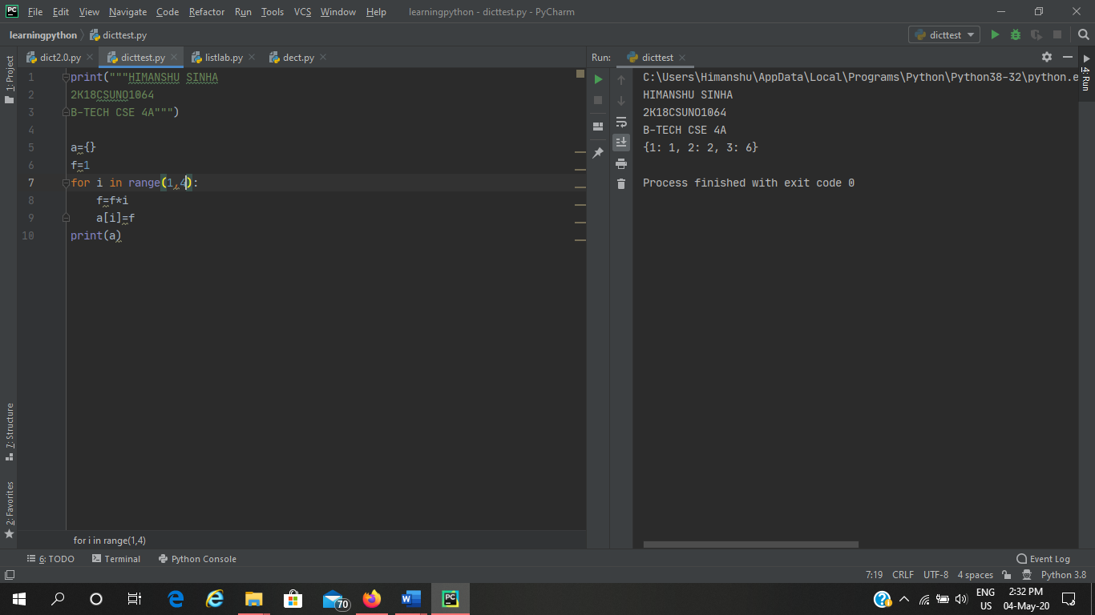

**Sets**

1. **Write a program to create a set**

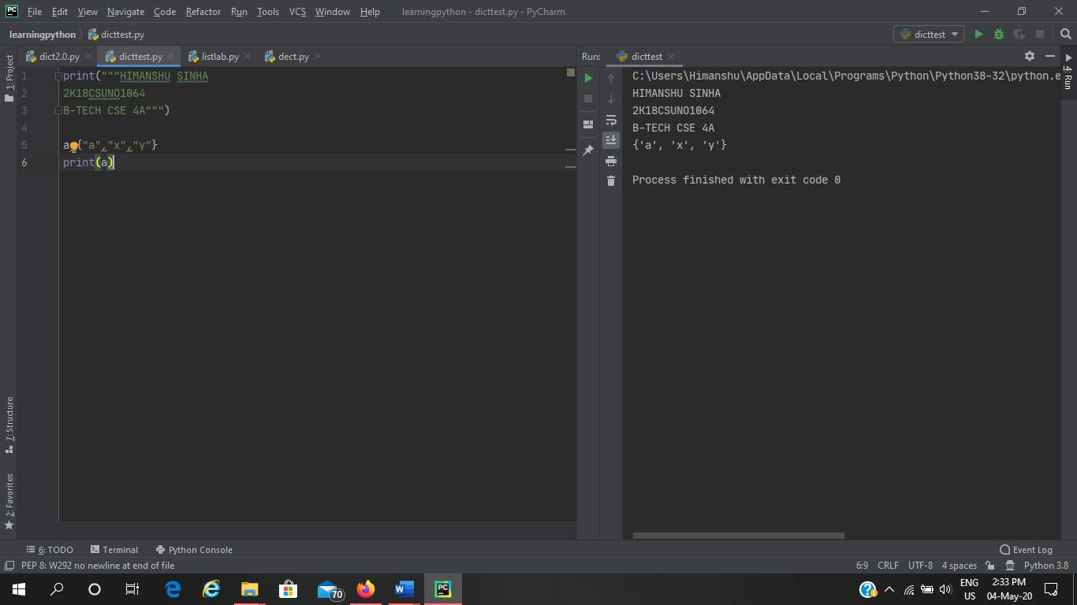

1. **Write a program to add an element to set**

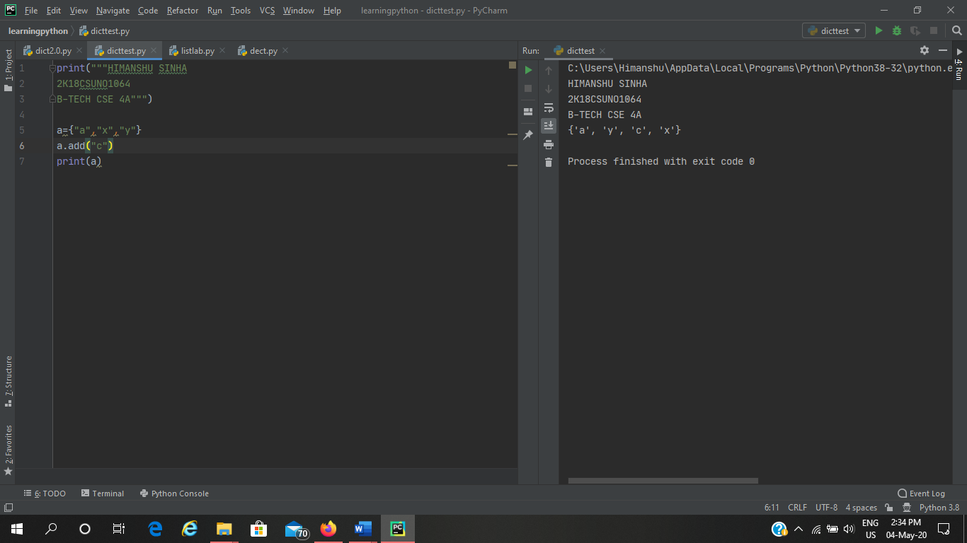

1. **Write a program to add multiple items using update function**

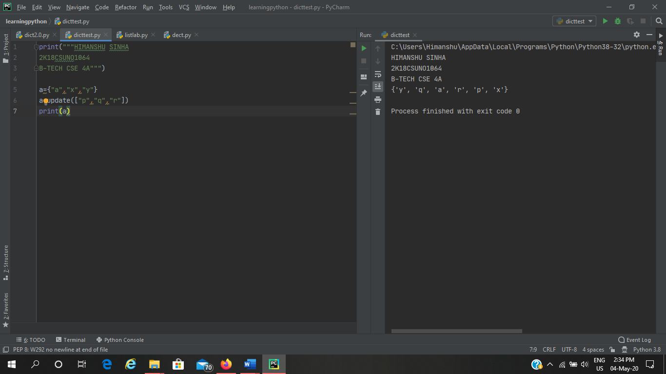

1. **Write a program to find length of a set**

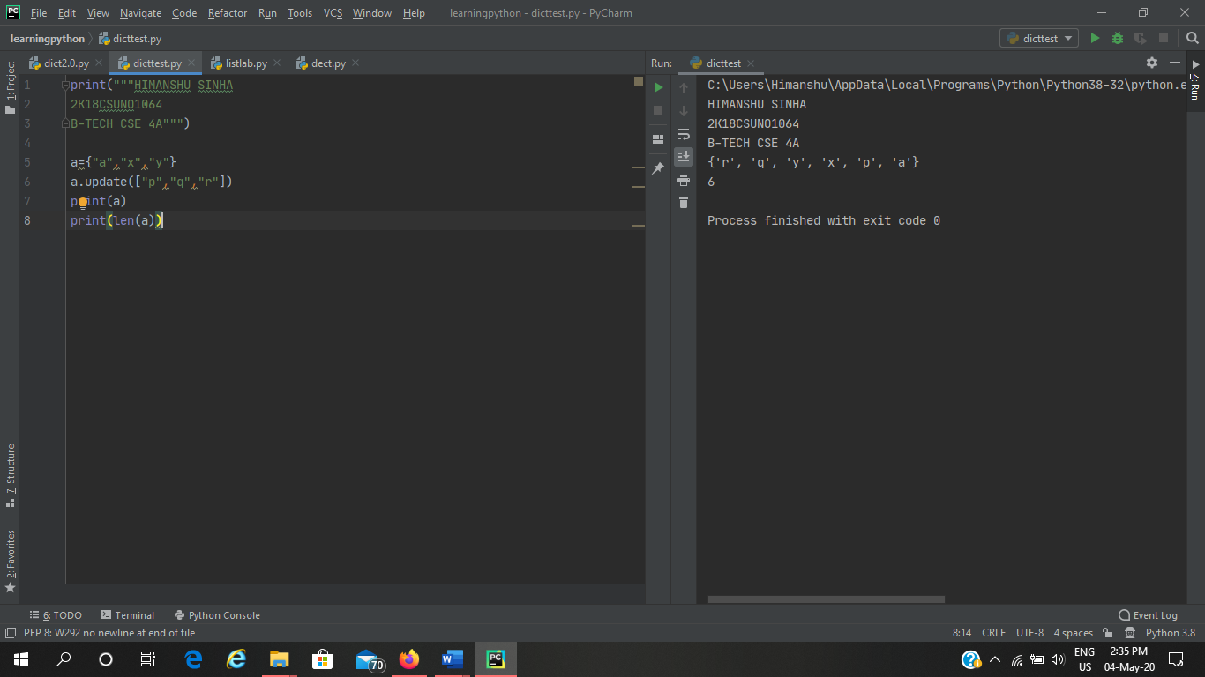

1. **Write a program to remove value from a set**

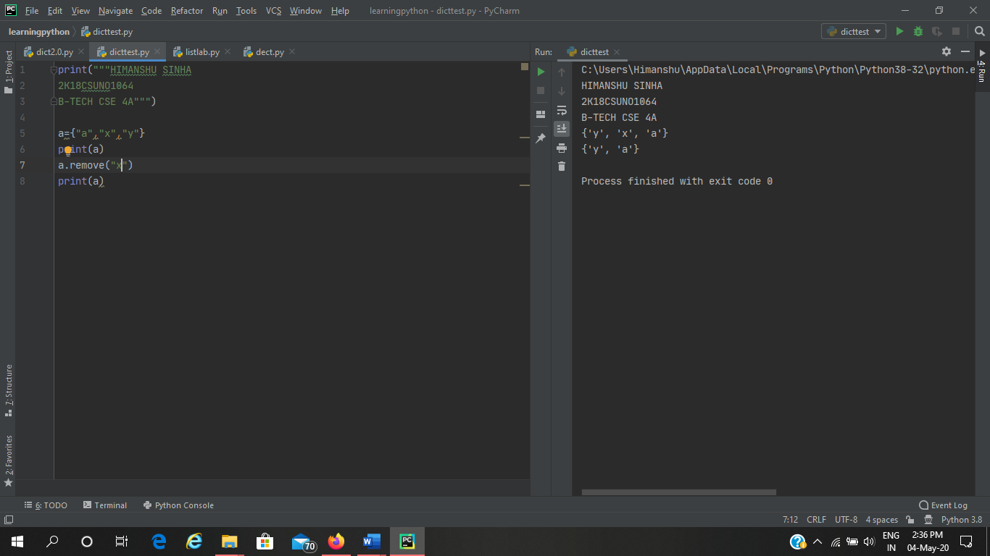

1. **Write a program to pop an element from a set**

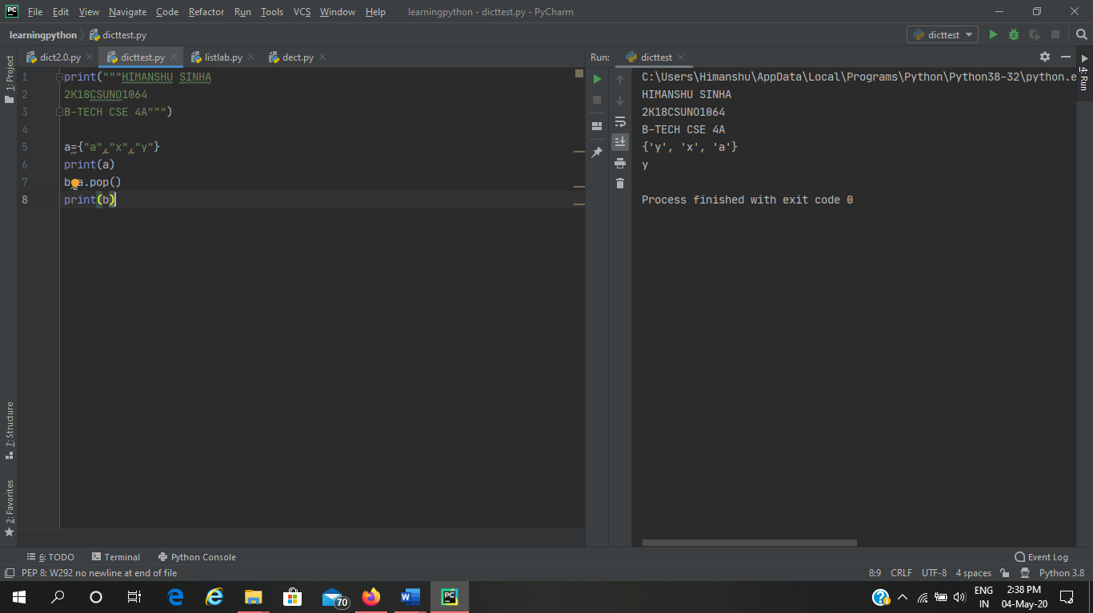

1. **Write a program to update a set**

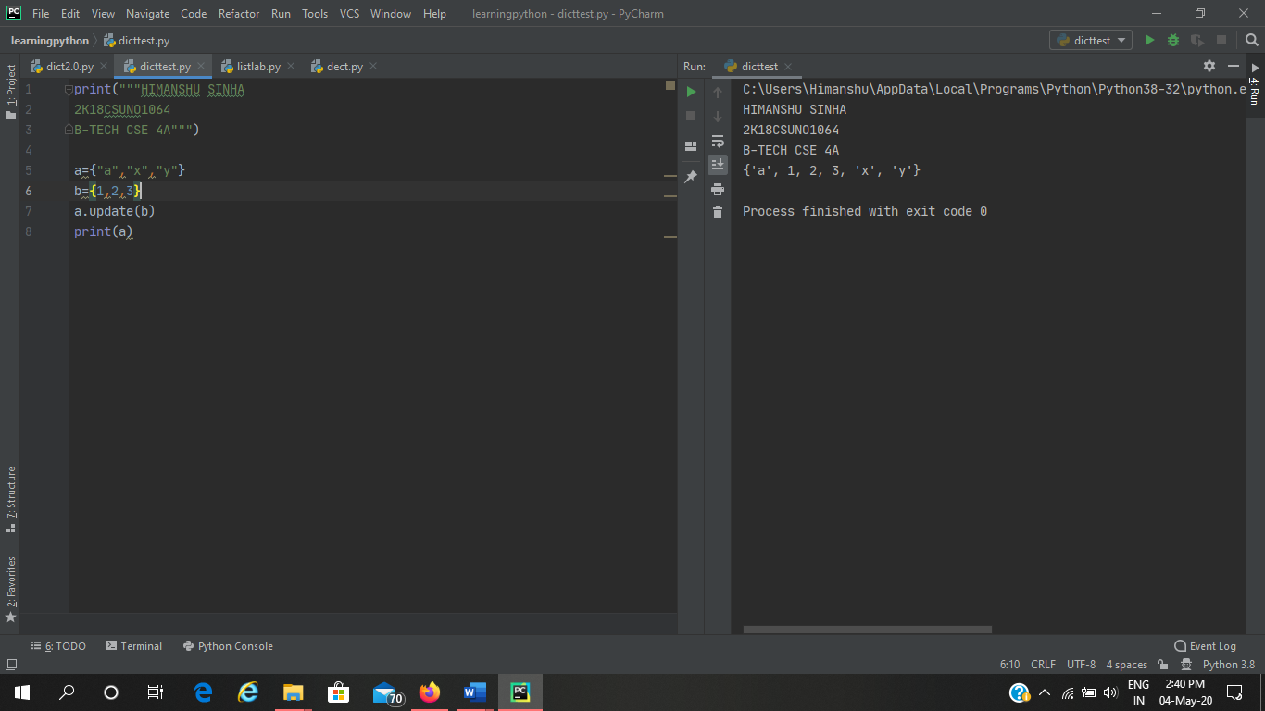

1. **Write a Python program to create an intersection of sets.**

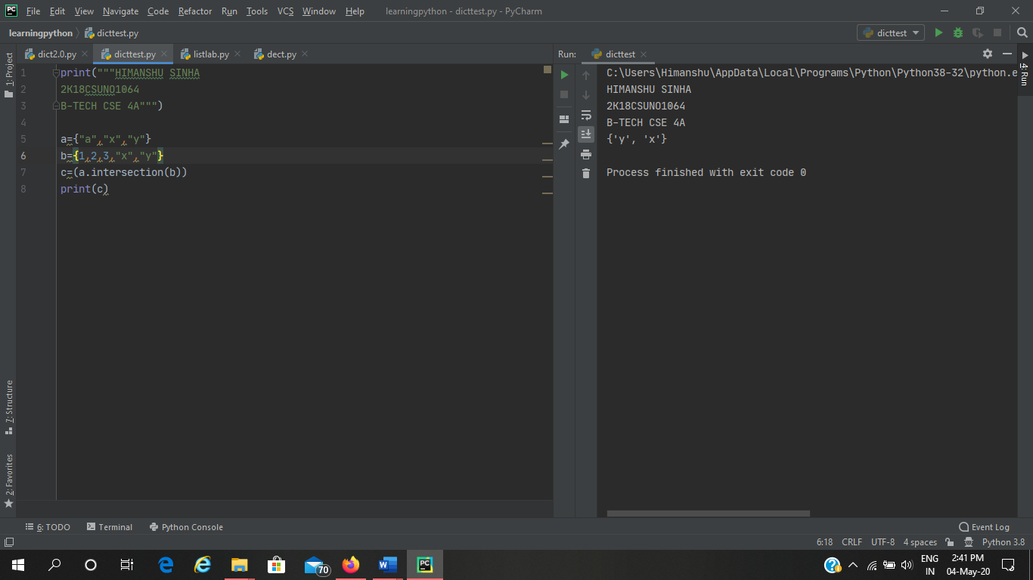

1. **Write a Python program to create a union of sets.**

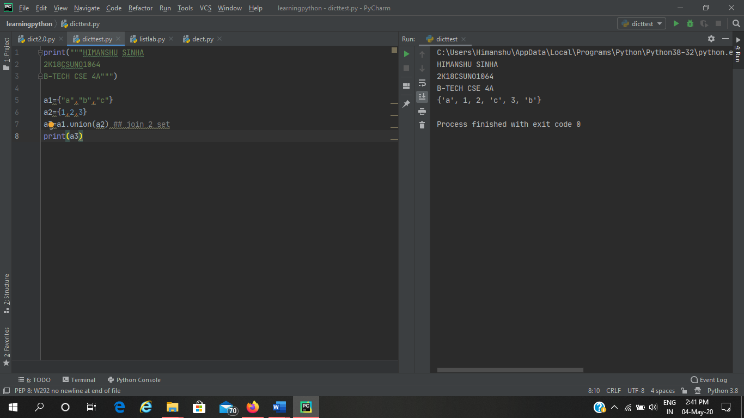

1. **Write a Python program to clear a set.**

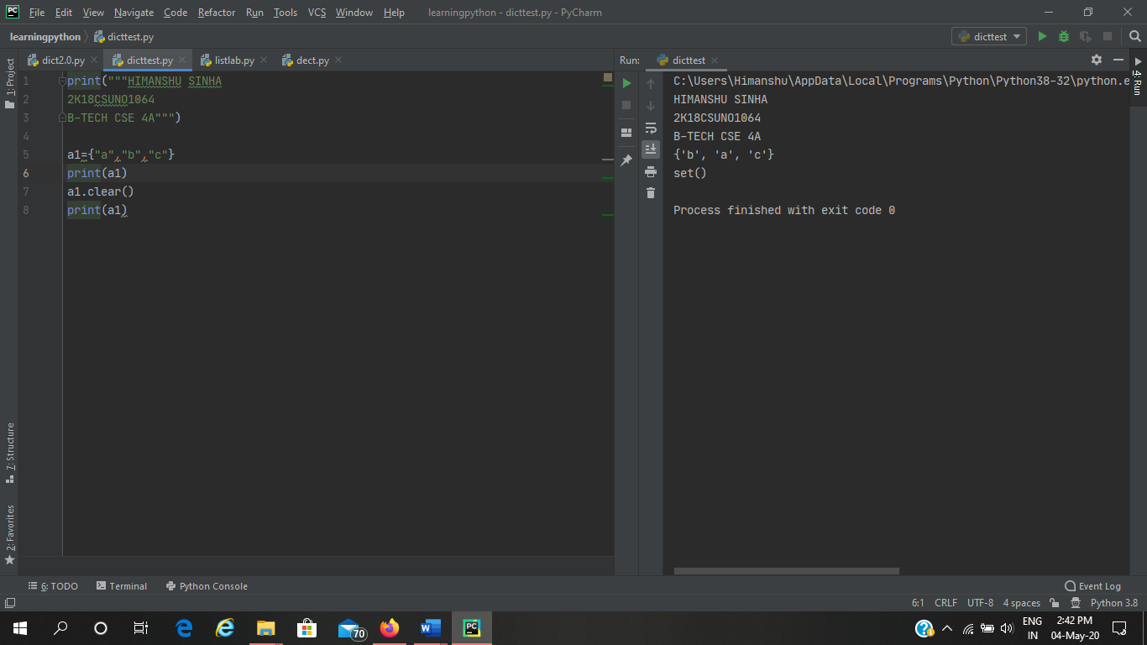

1. **Write a Python program to issubset and issuperset.**

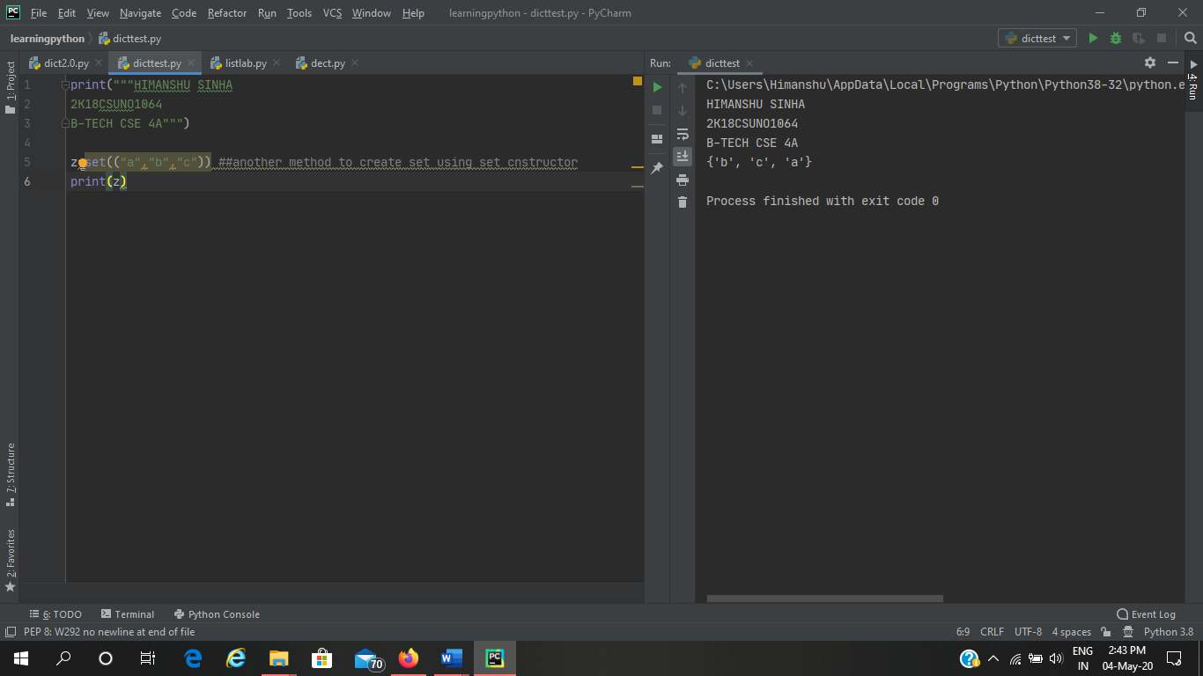

1. **Write a Python program to create set difference.**

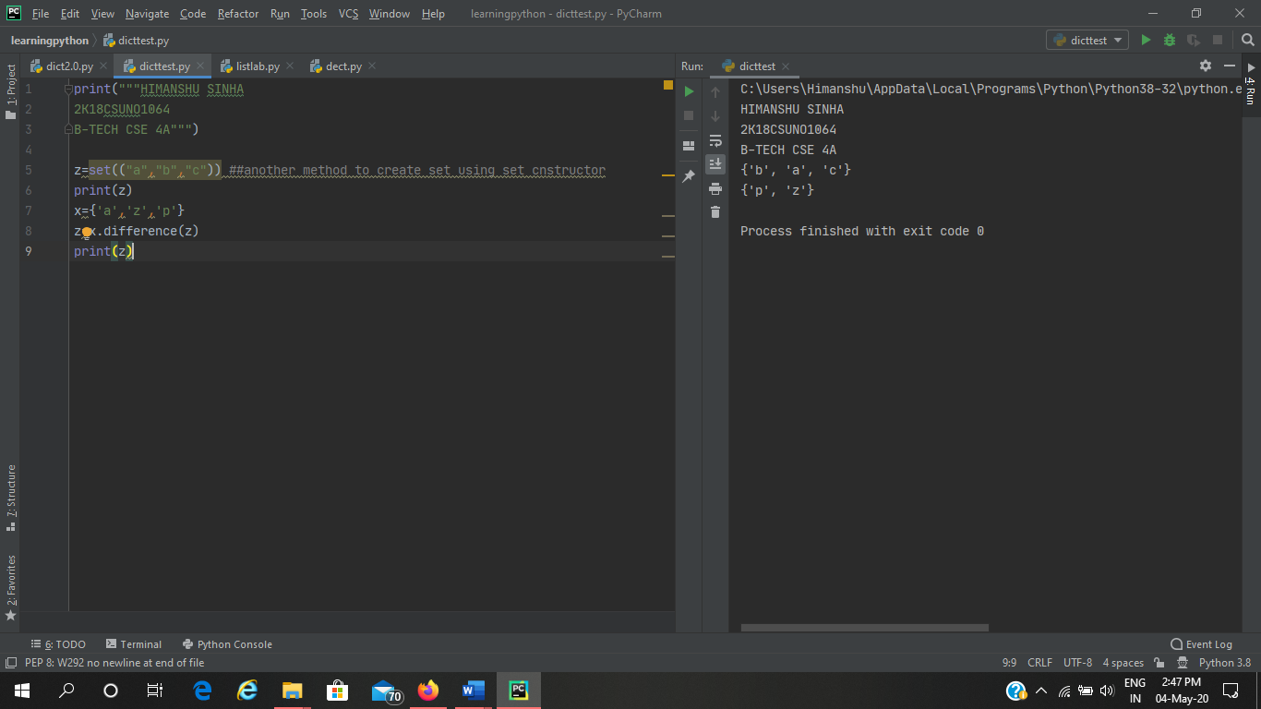

1. **Write a Python program to create a symmetric difference**

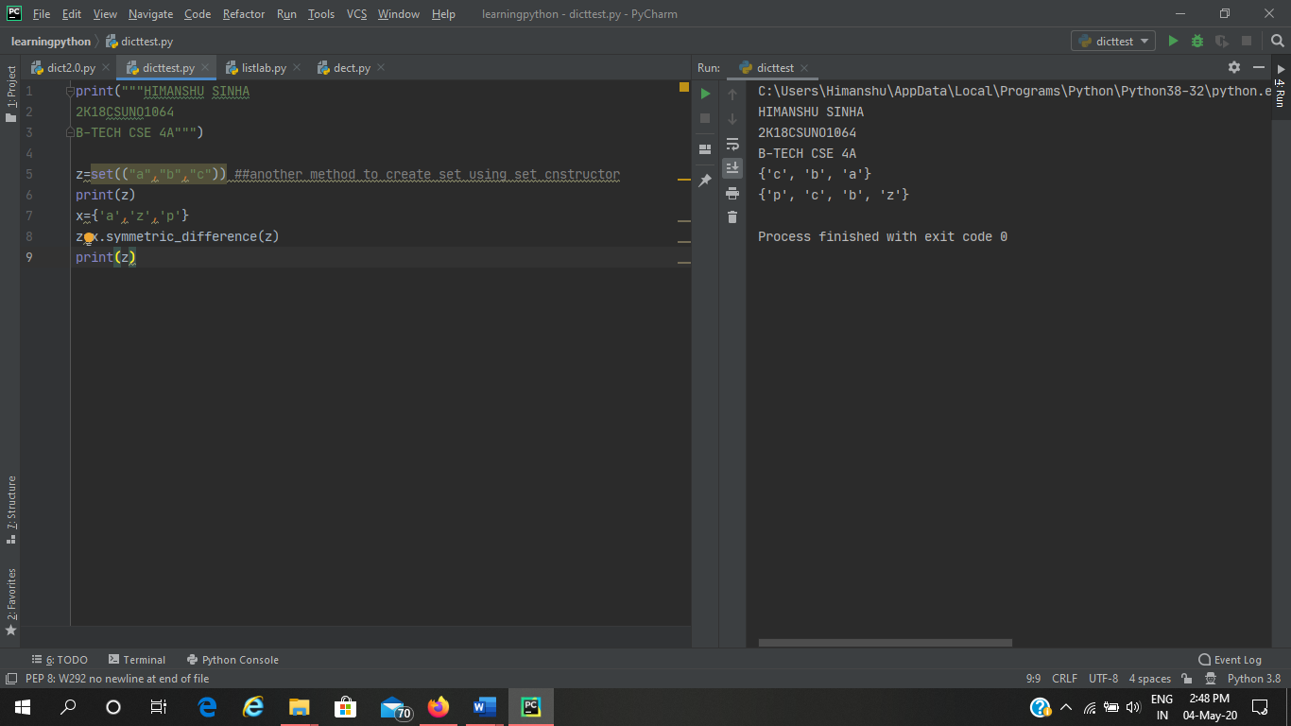

**FUNCTION PYTHON LAB**

**Q1**

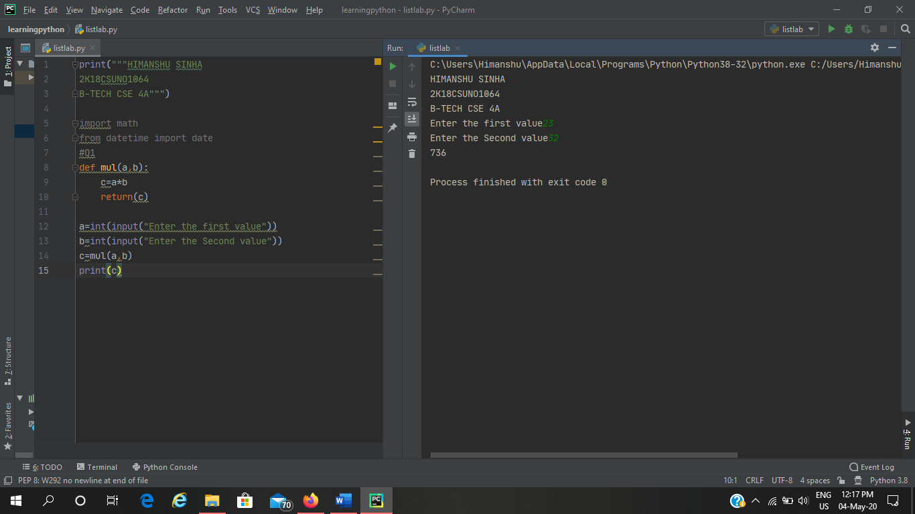

**Q2**

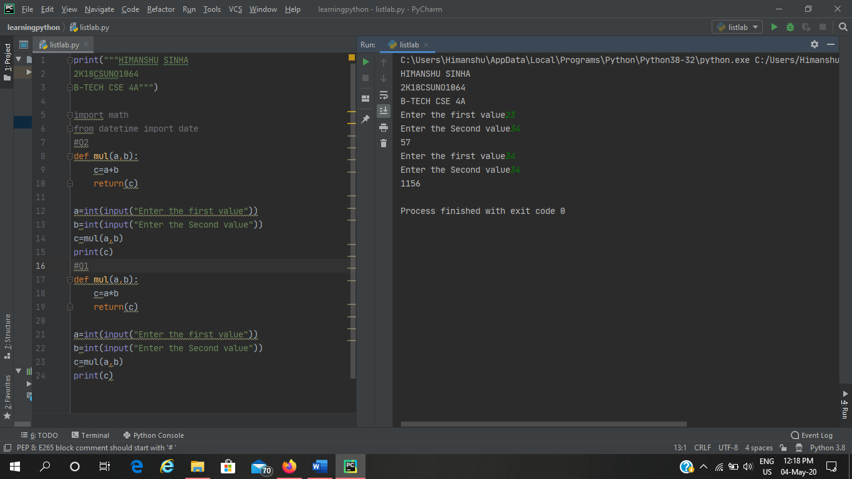

**Q3**

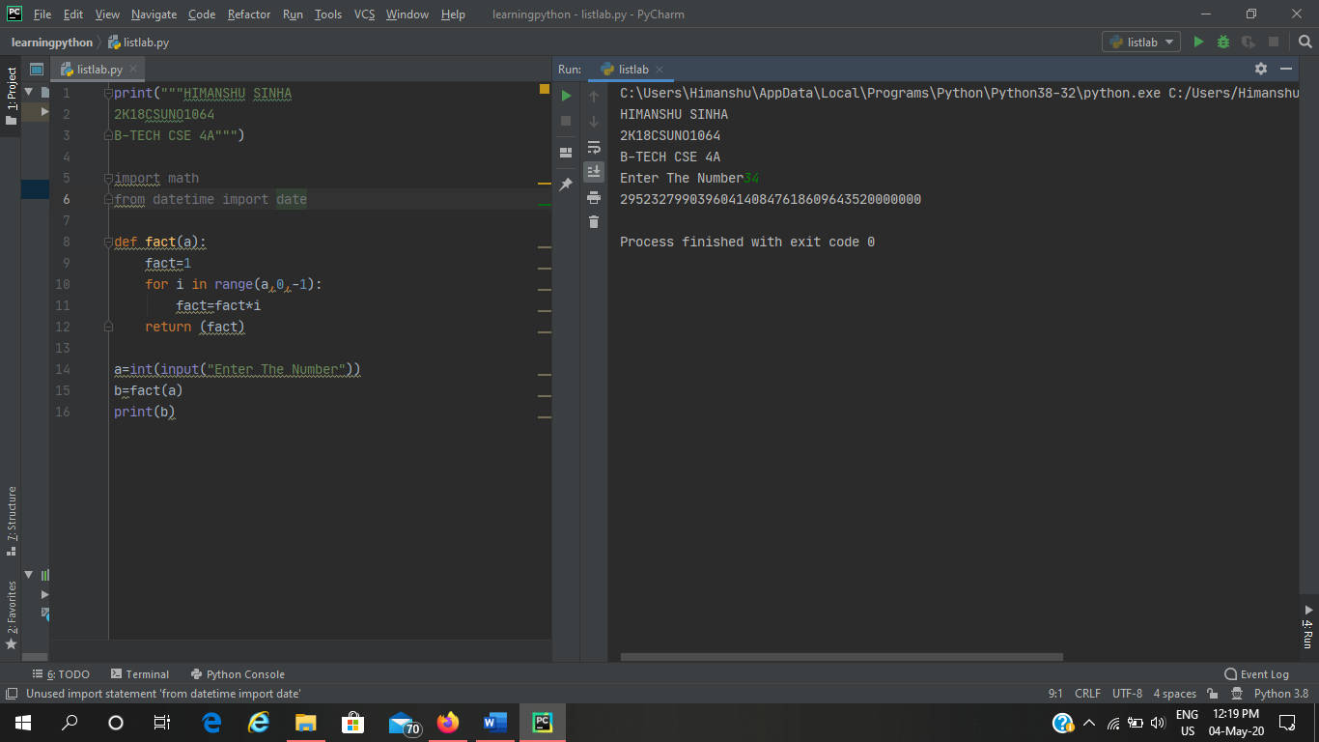

**Q4**

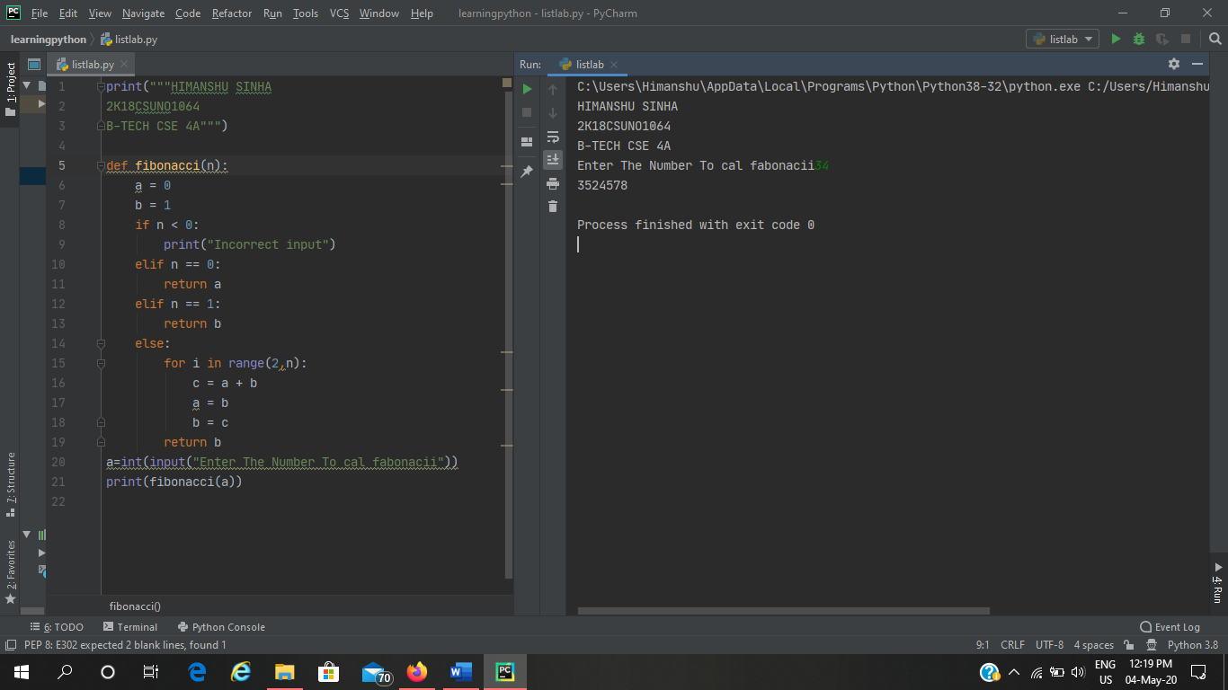

**Q5**

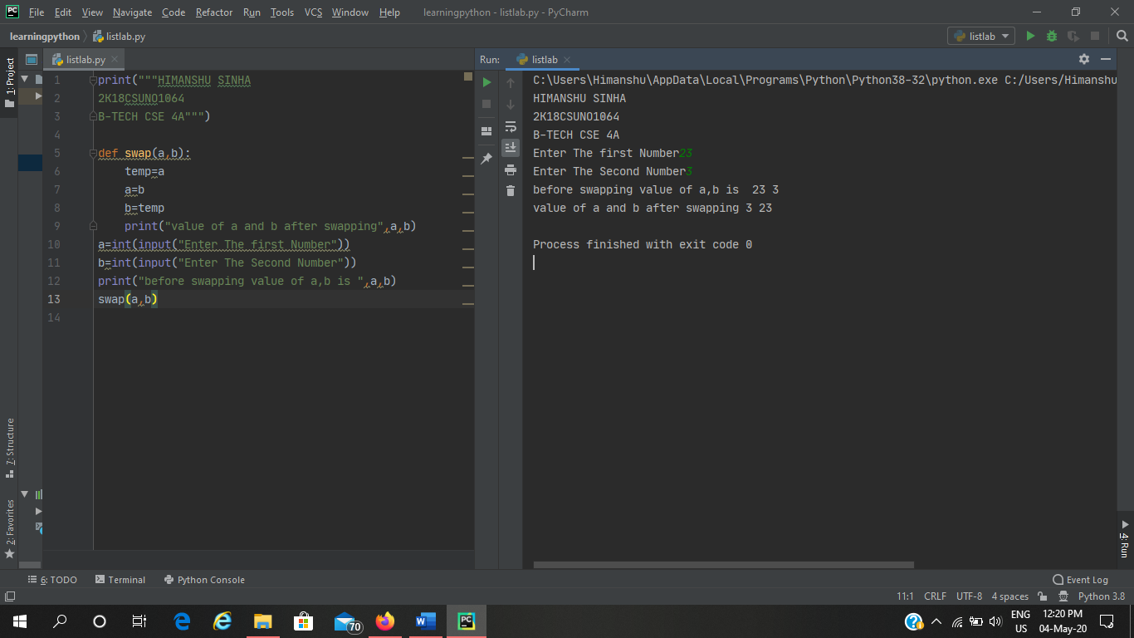

**Q6**

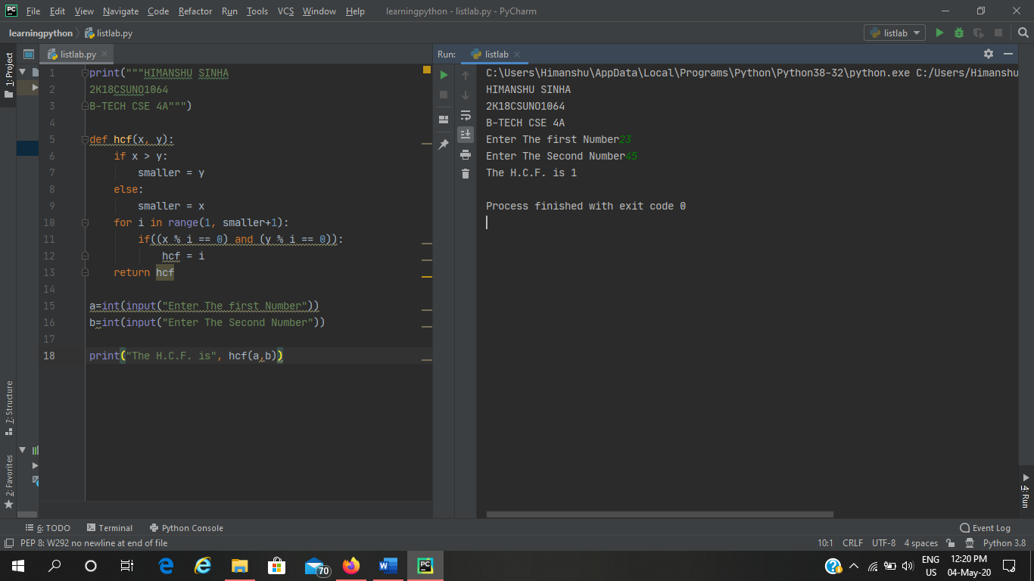

**Q7**

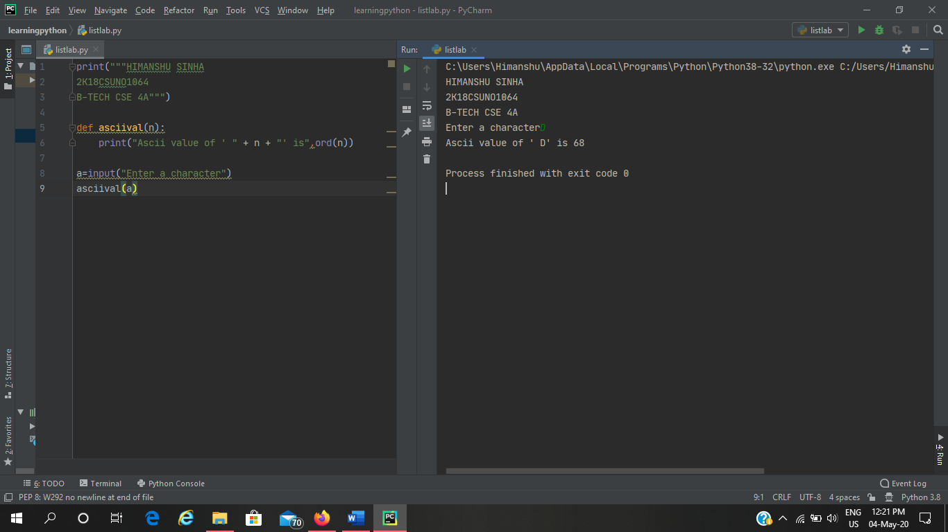

**Q8**

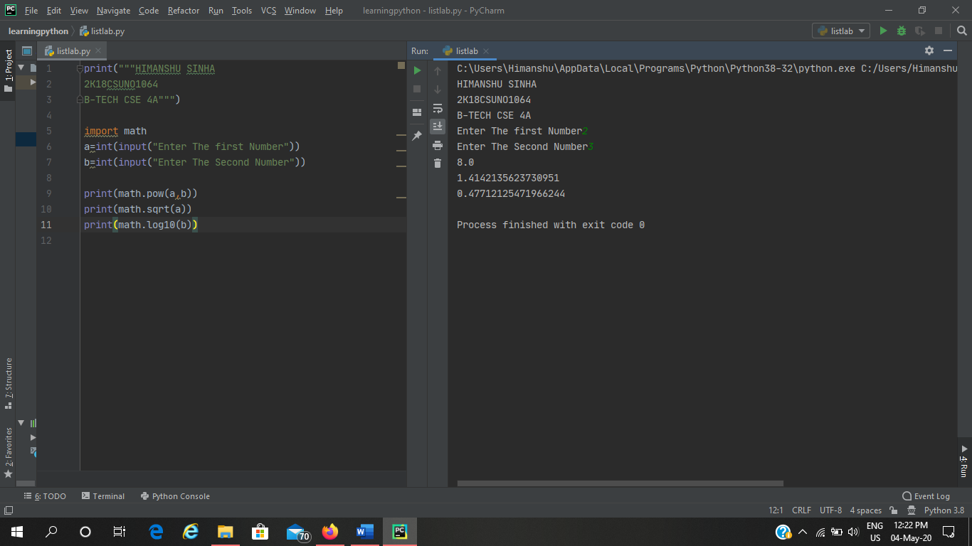

**Q9**

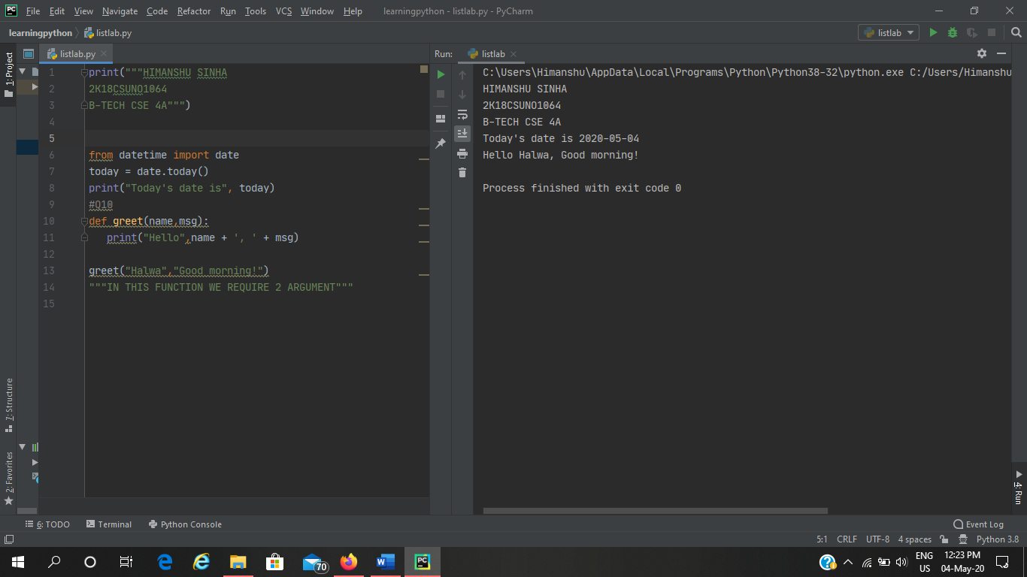

**Q10**

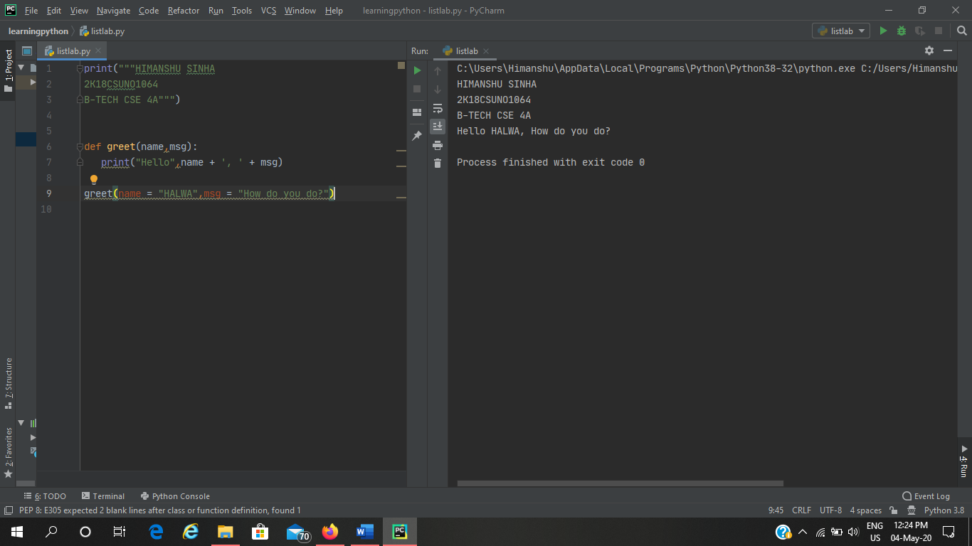

**Q11**

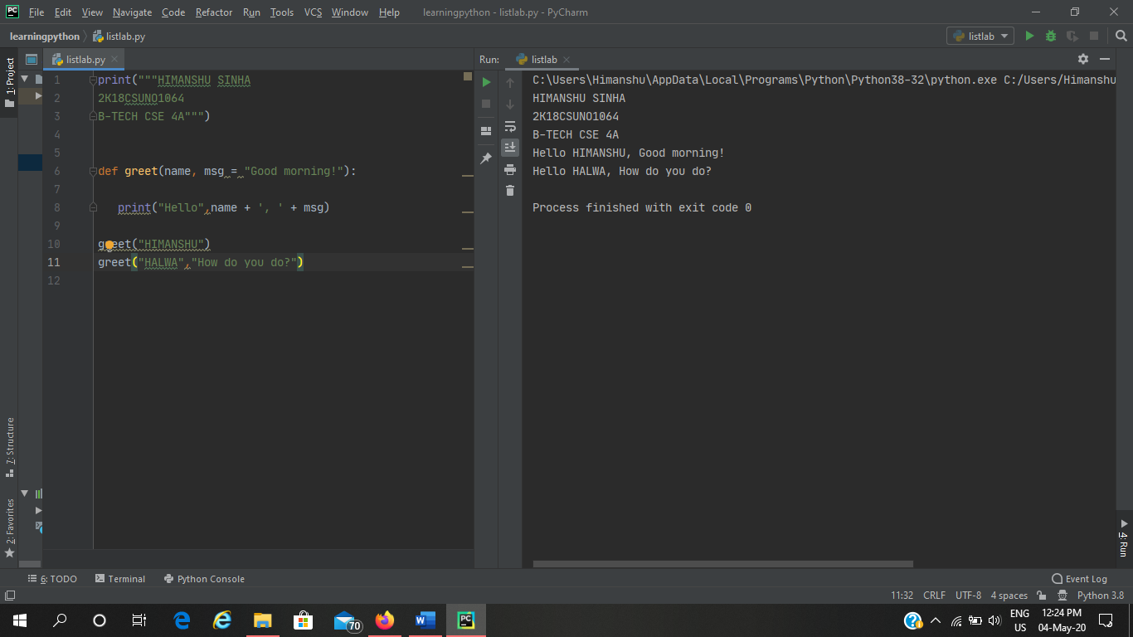

**Q12**

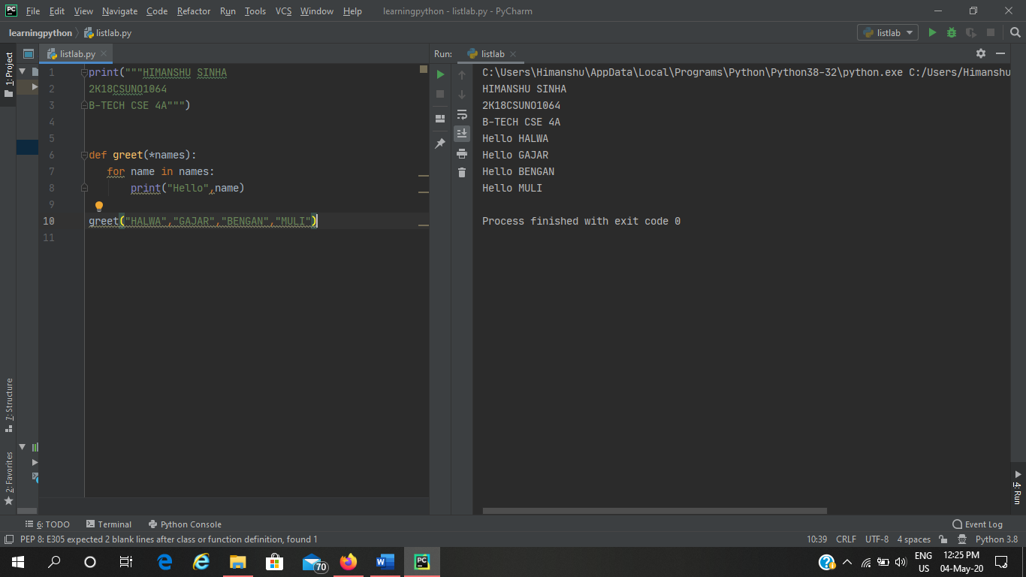

**Q13**

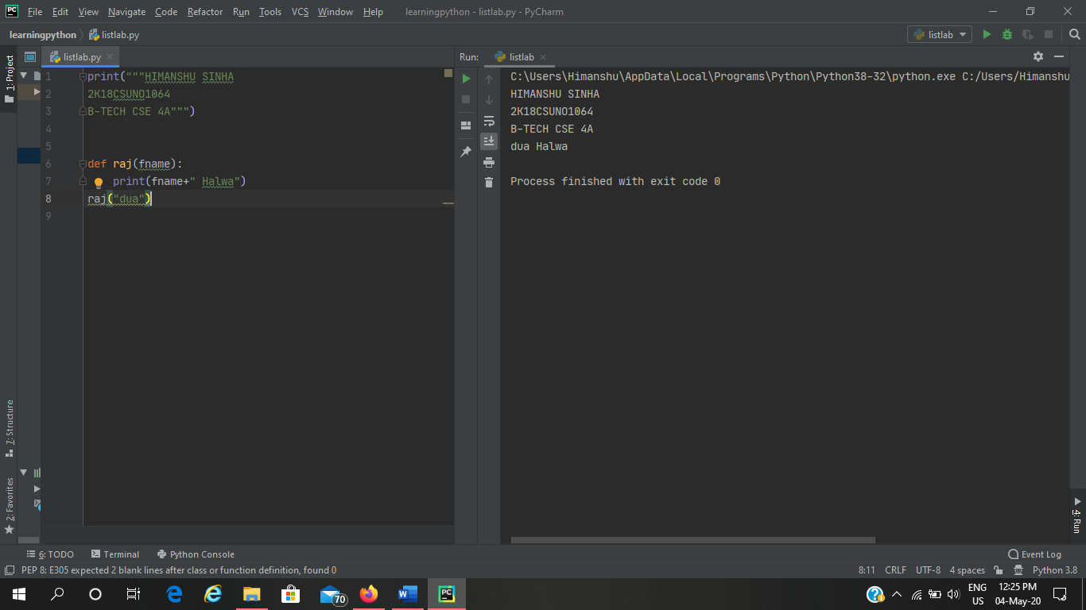

**Q14**

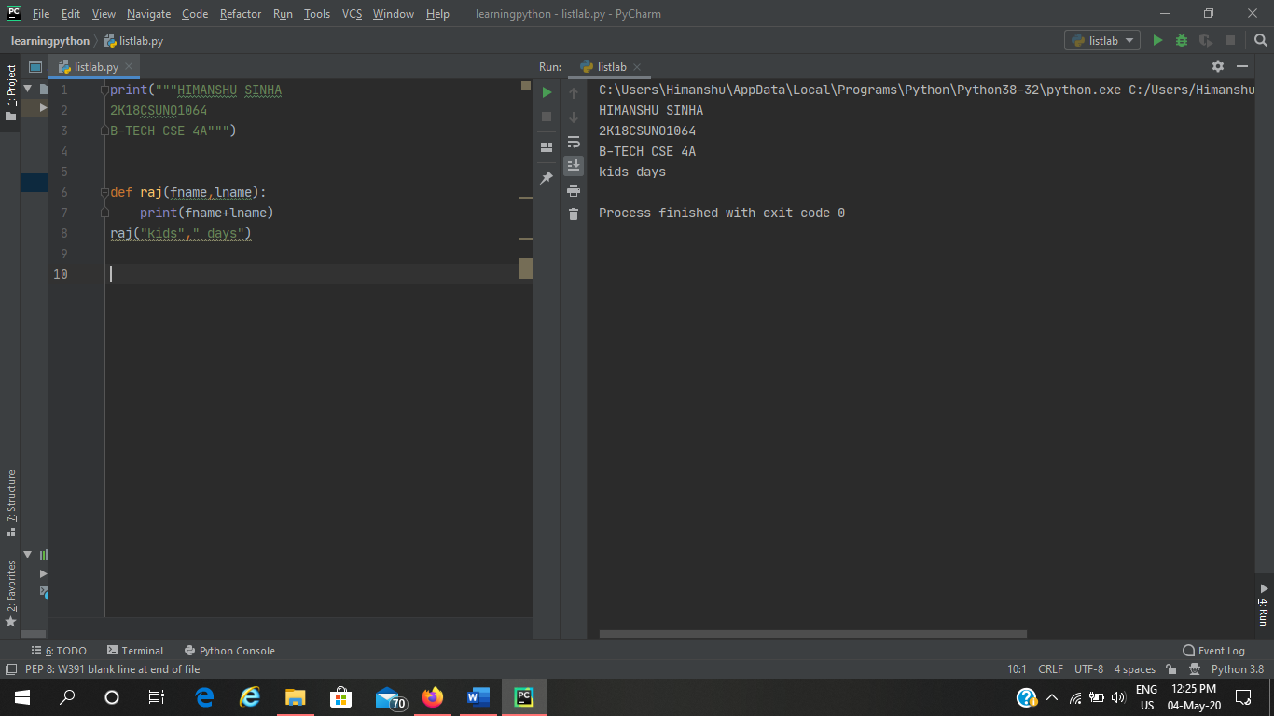

**Q15**

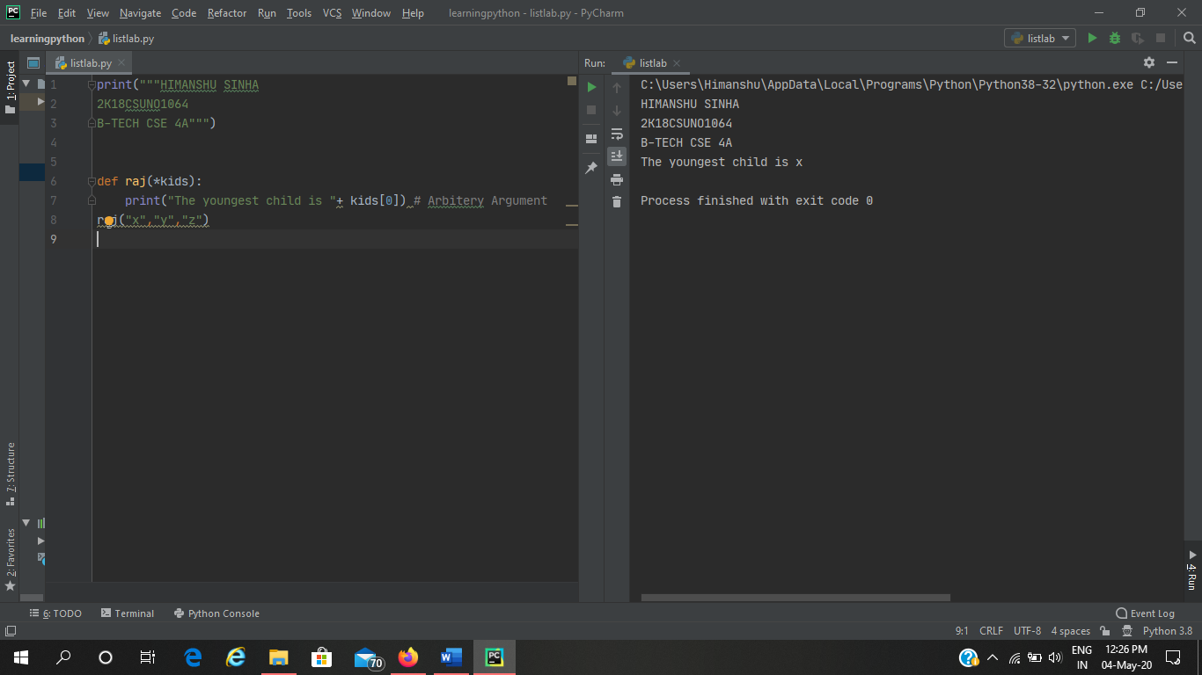

**Q16**

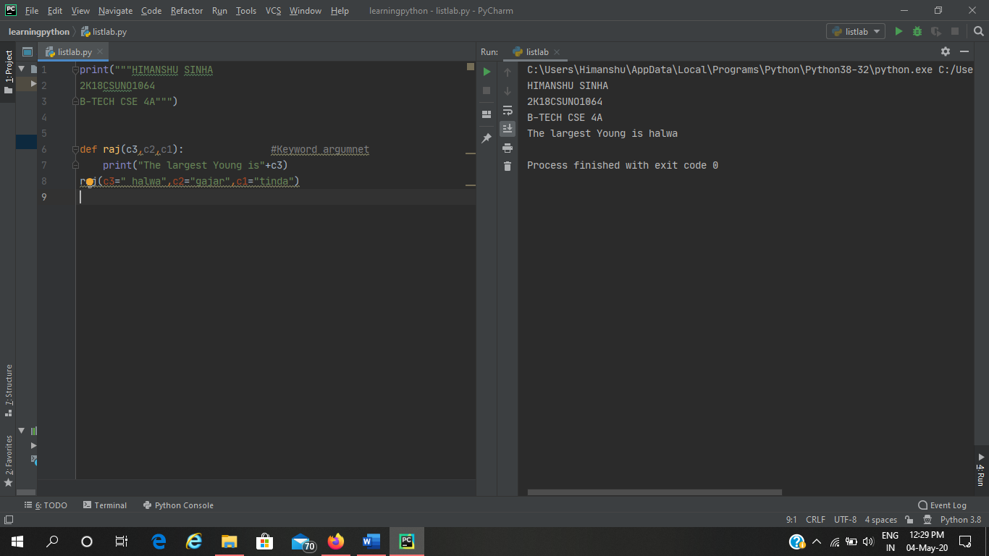

**Q17**

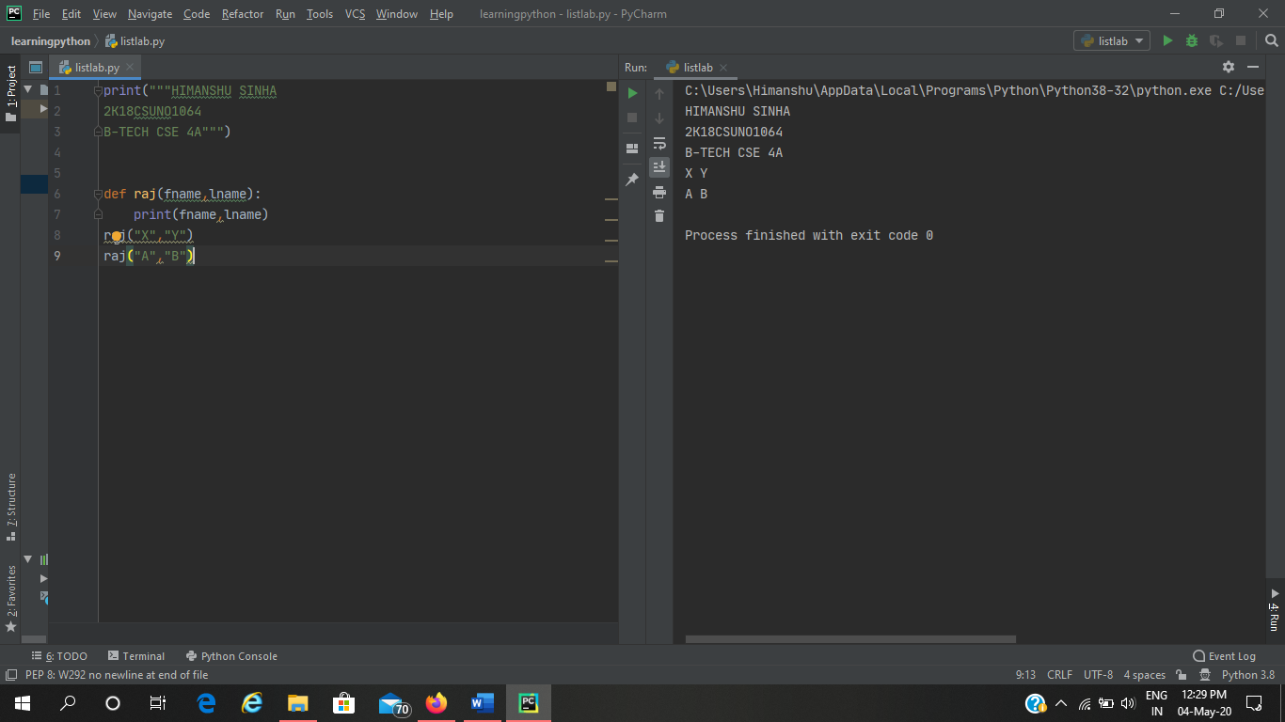

**Q18**

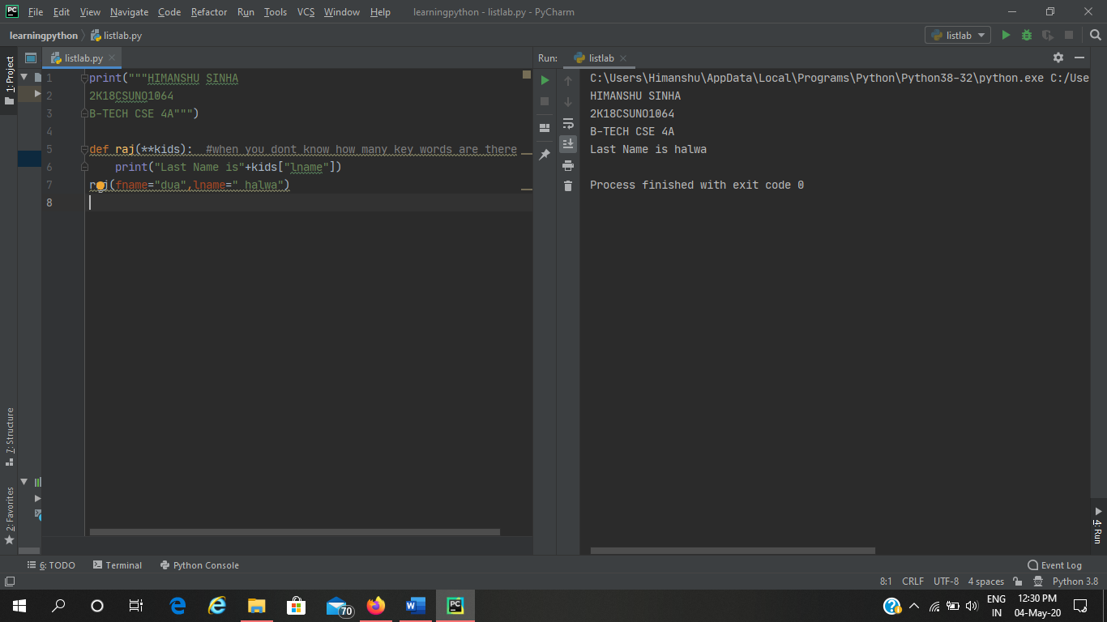

**Q19**

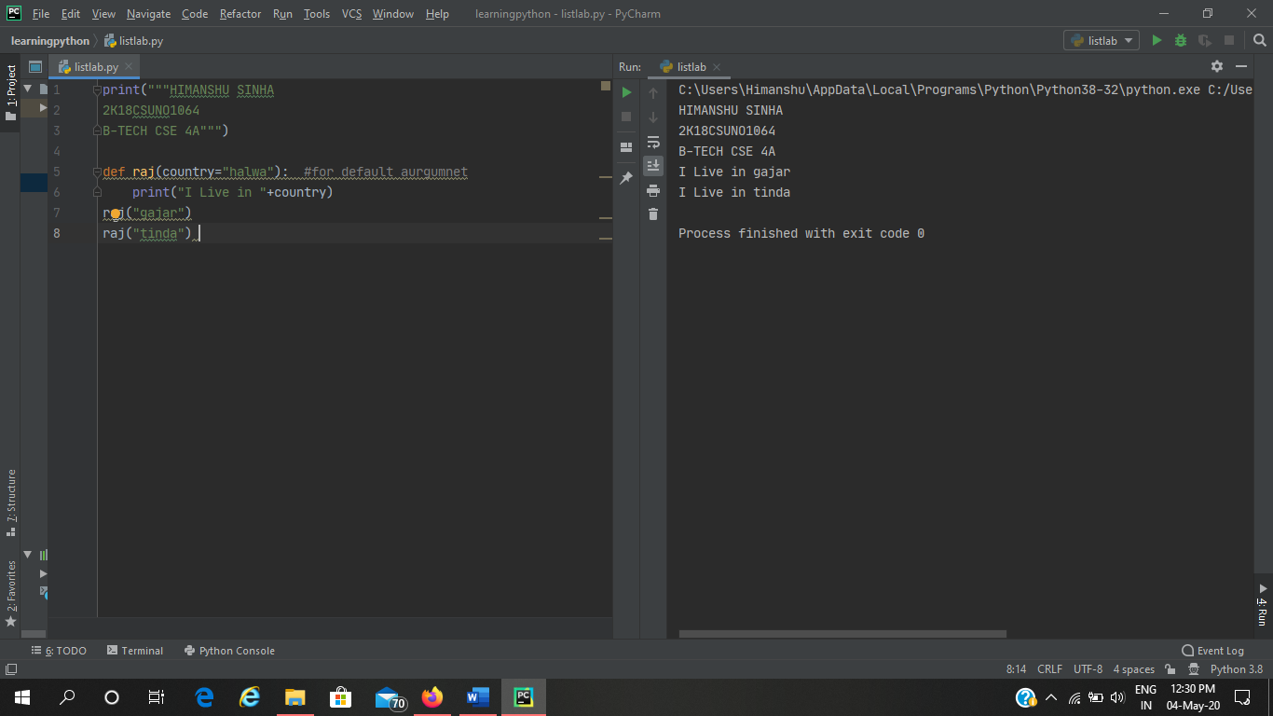

**Q20**

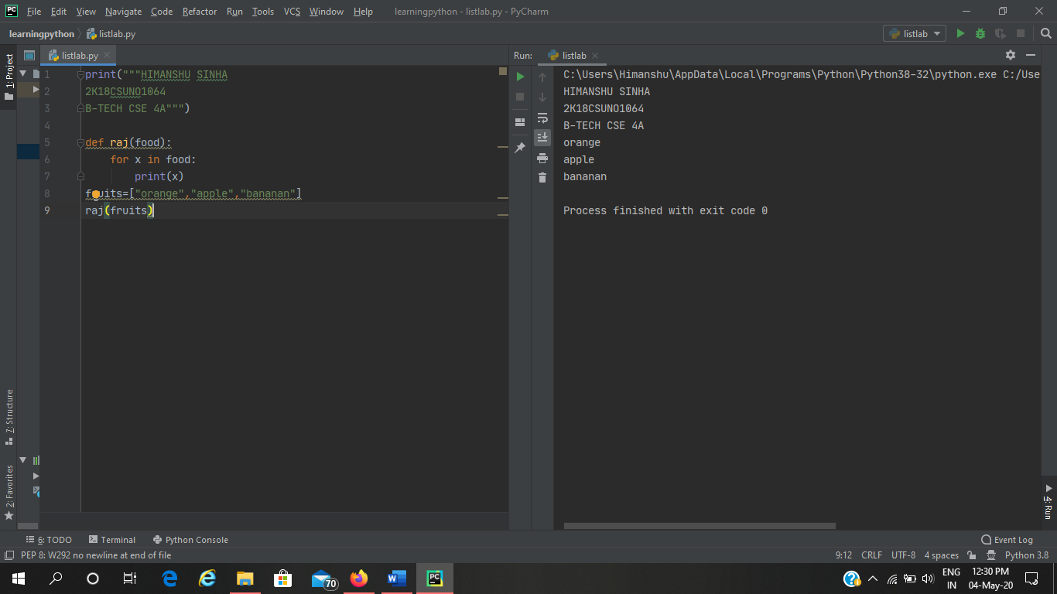

**Q21**

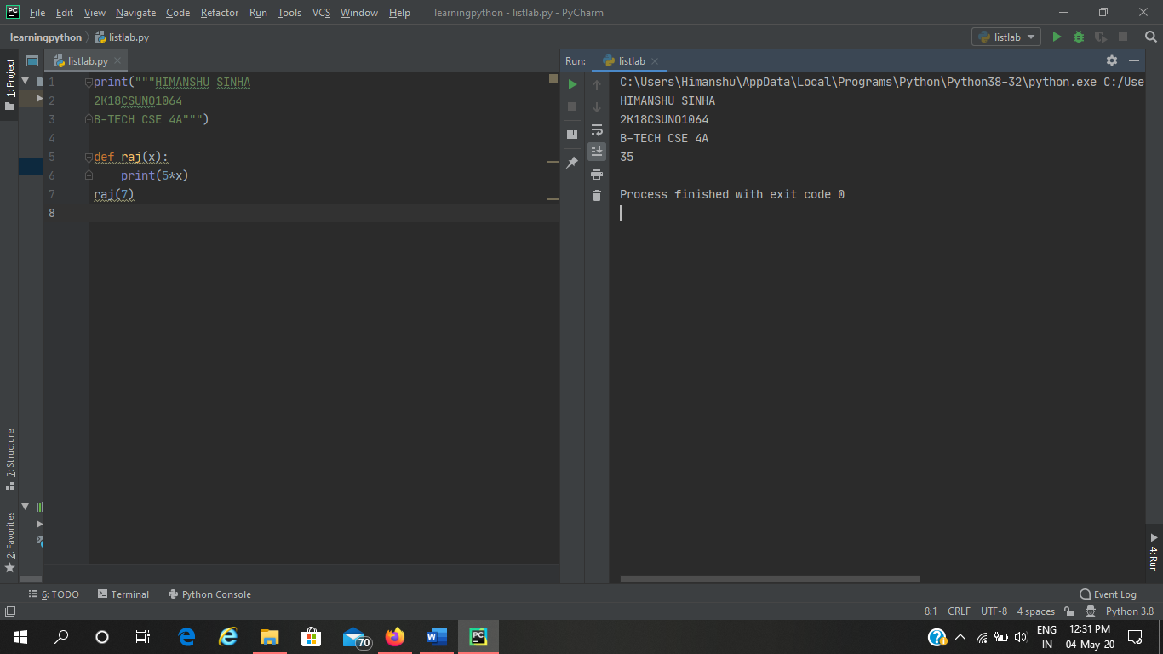

**Q22**

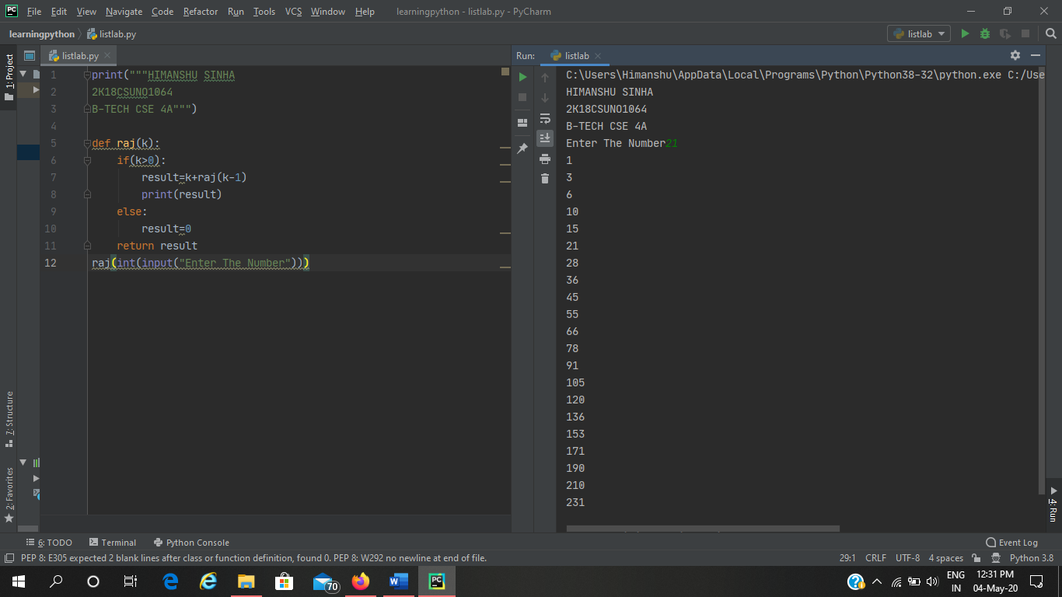

**CLASS PYTHON LAB**

**Q1-**

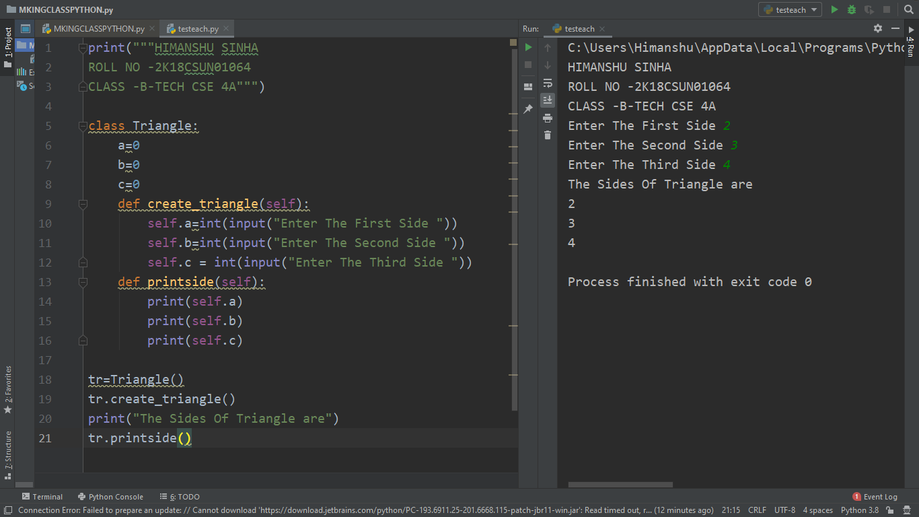

**Q2**

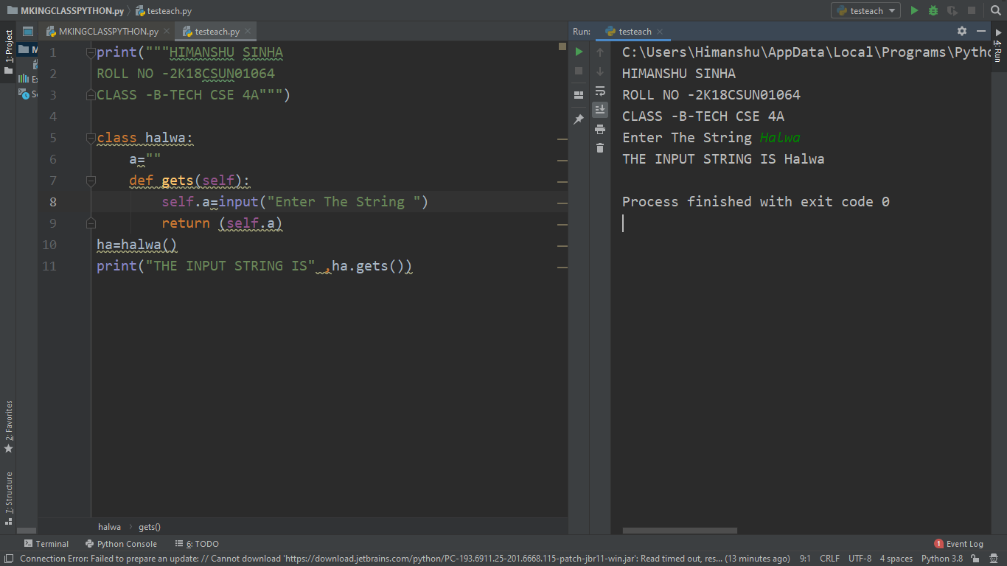

**Q3**

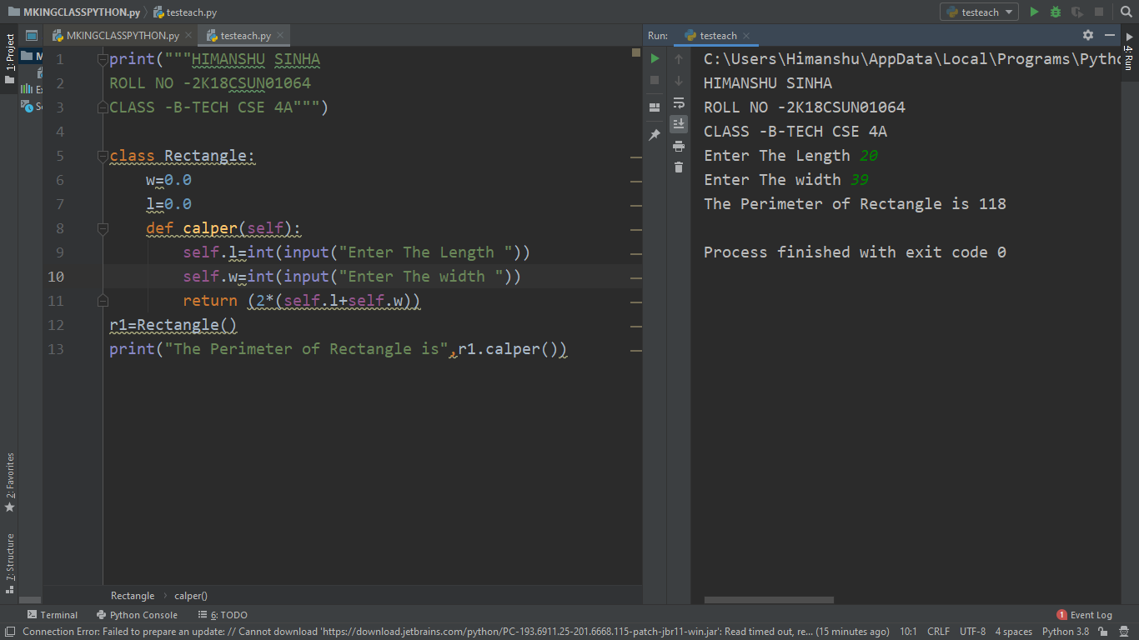

**Q4**

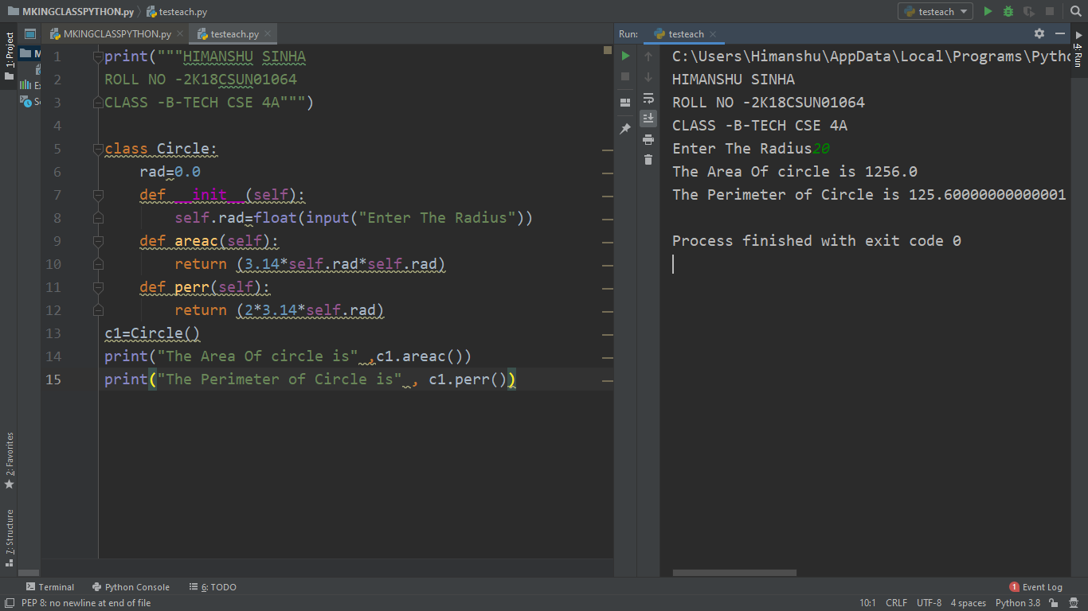

**Q5**

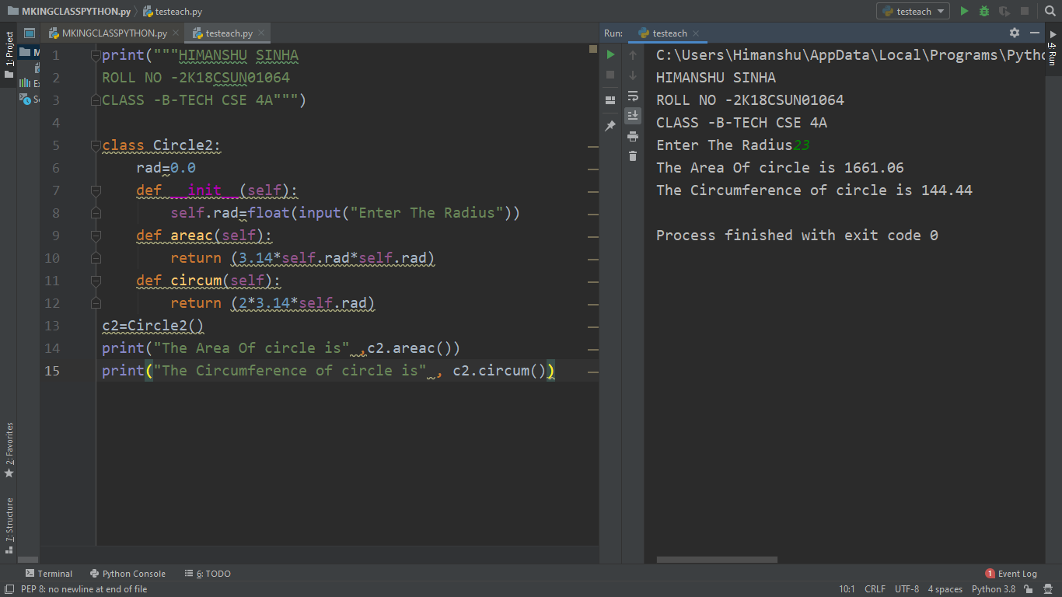

**Q6**

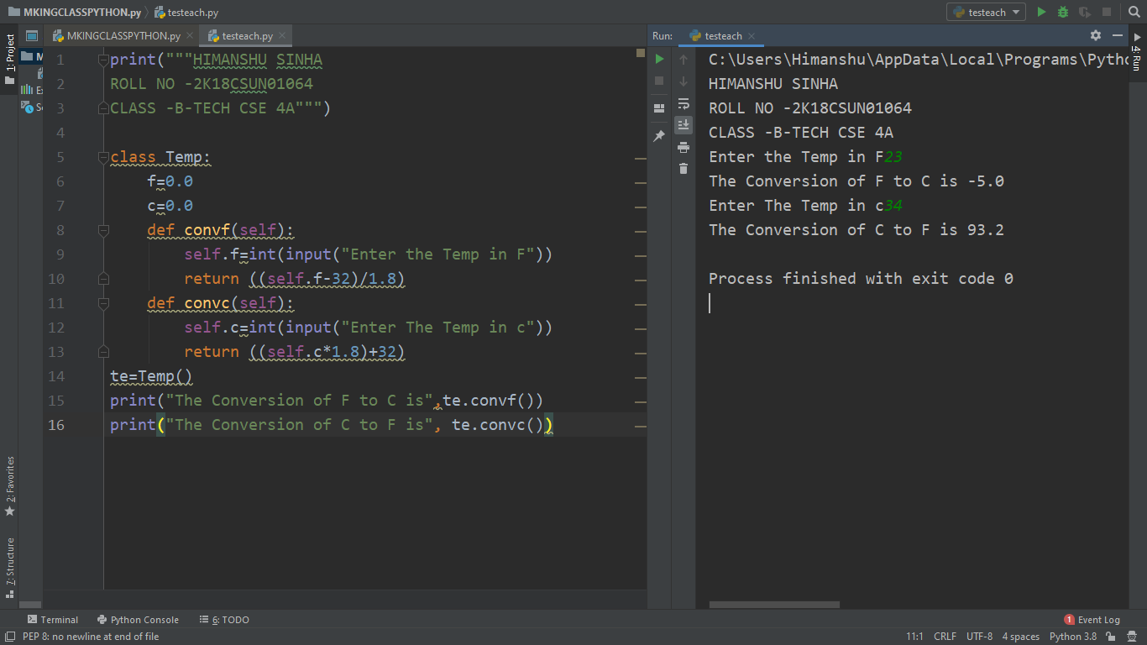

**Q7**

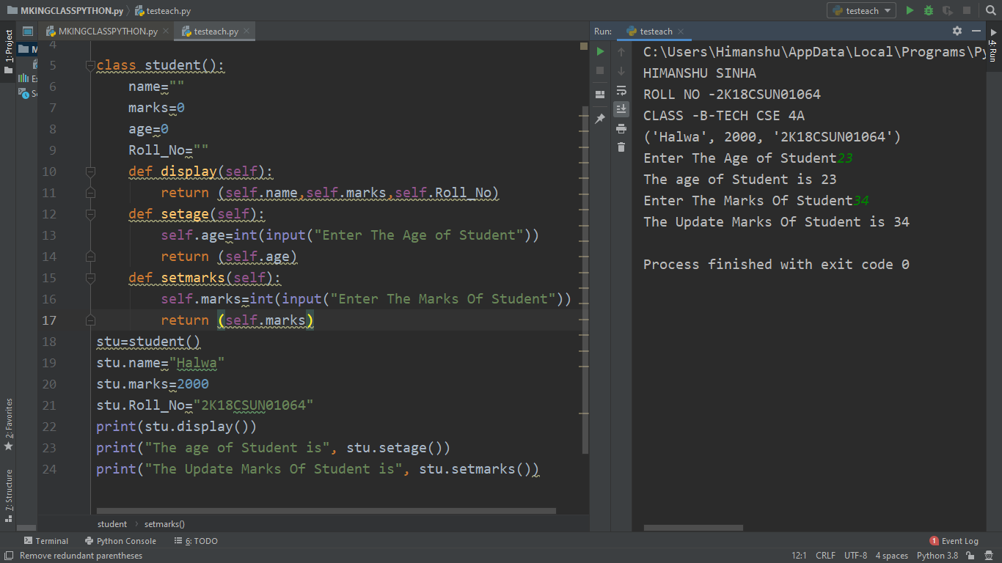

**Q8**

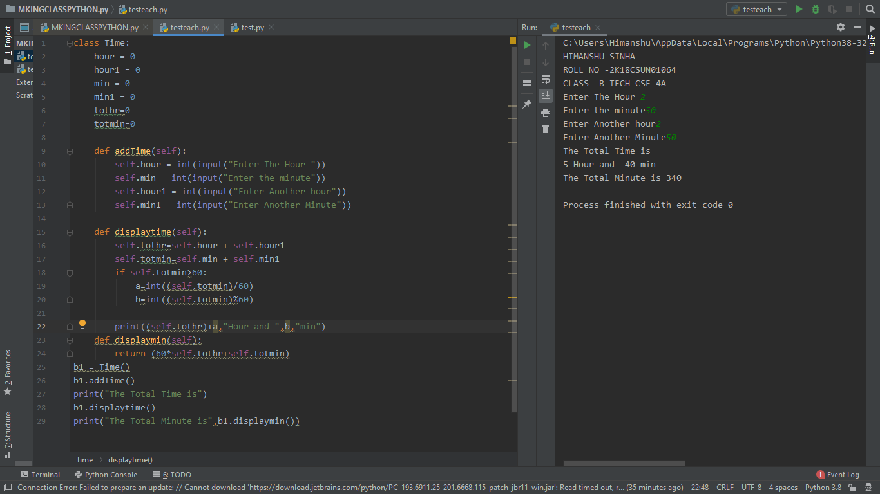

**Q9**

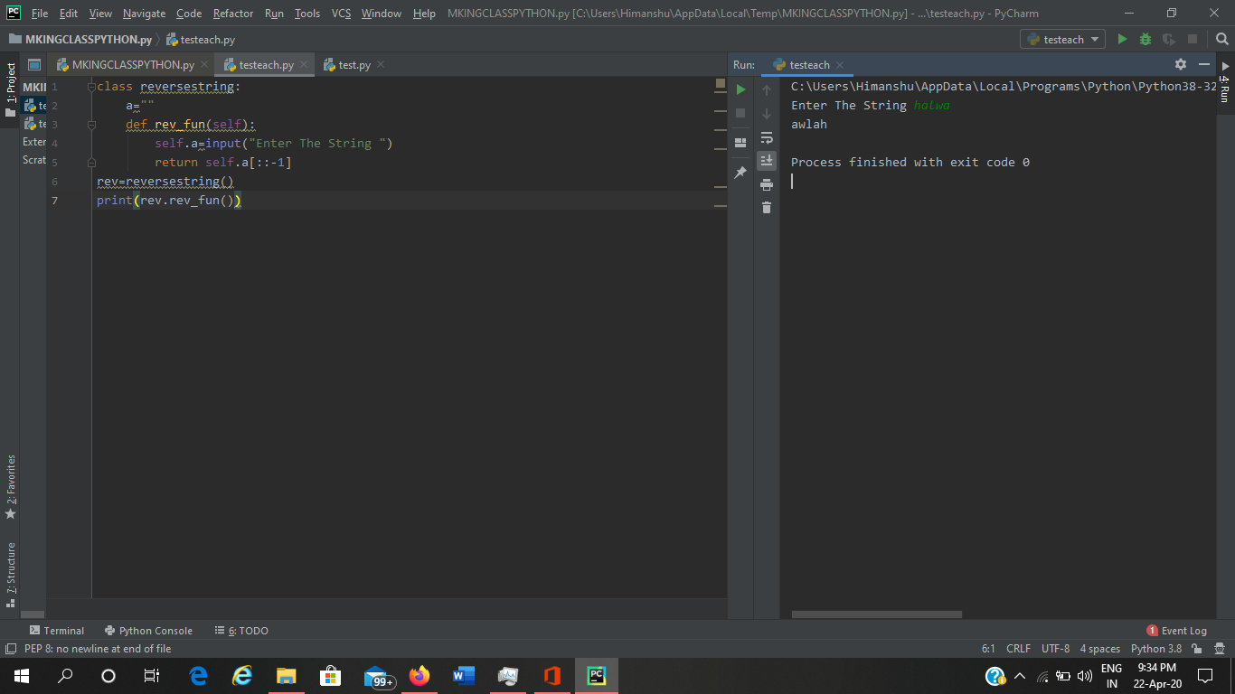

**INHERITANCE IN PYTHON**

1. **Write a Python program that has a class Animal with a method legs(). Create two subclasses Tiger and Dog, access the method leg explicitly with class Dog and implicitly with the class Tiger.**



1. **Write a Python program to create a class Employee. Define two subclasses: Engineer and Manager. Every class should have method named printDesignation() that prints Engineer for Engineer class and Manager for Manager Class.**



1. **Write a Python program to demonstrate classes and their attributes.**



1. **Write a Python program to demonstrate Inheritance and method overriding.**



1. **Write a Python program to demonstrate multiple Inheritance.**

